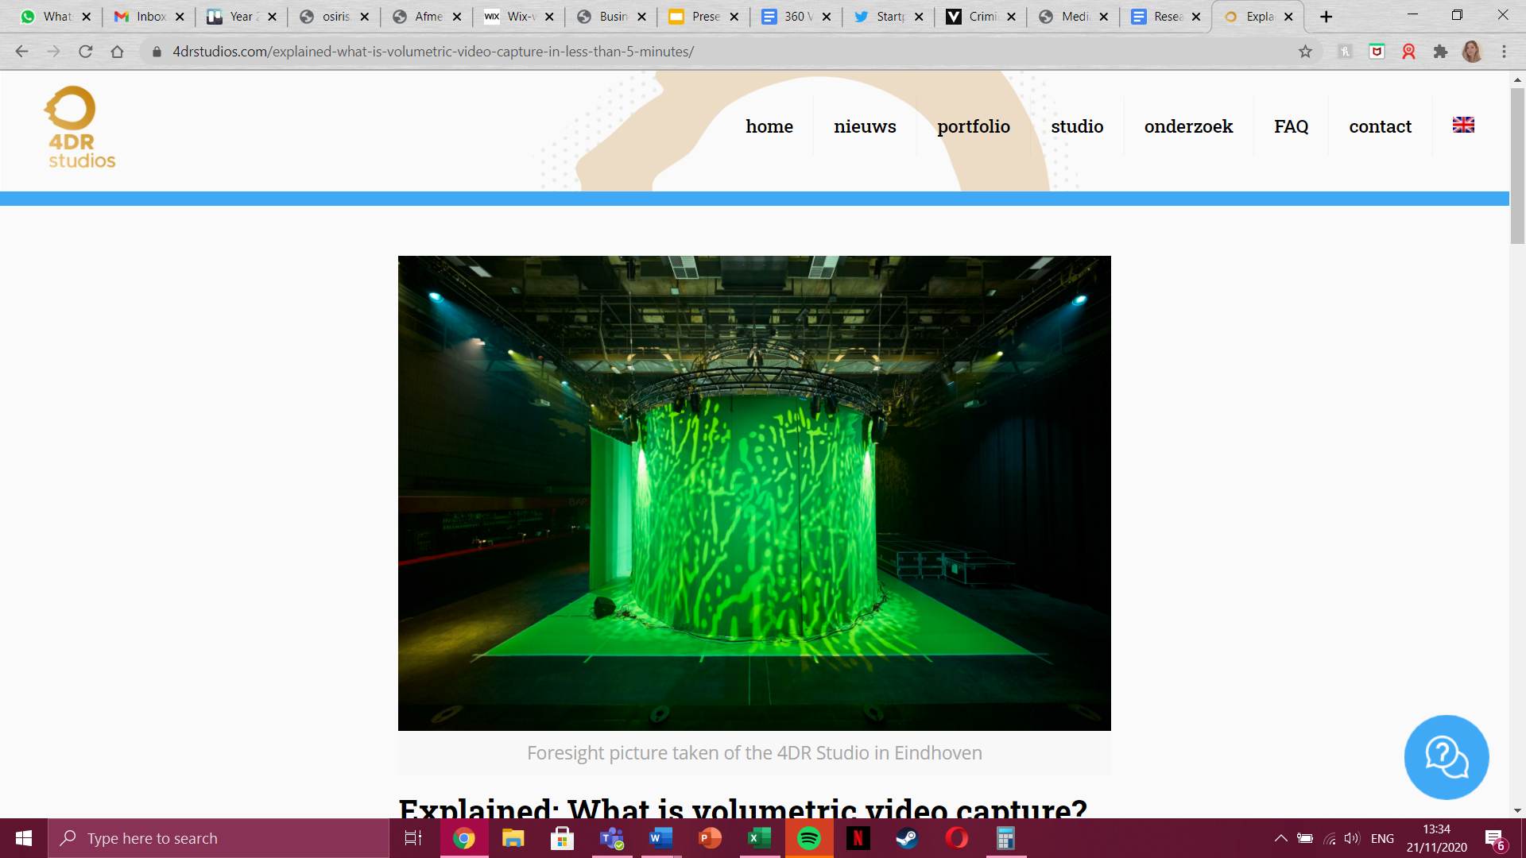

Project: Being There

Volumetric Character Design Document

360 Video and Storyboards

Collaboration between UDEM & BUAS

**Table of Contents**

Description of the project.………………………………………………………………

**1º Volumetric Character Design**

Introduction……………………………………………………………………………..…

Volumetric Capture………………………………………………………………………..

The characters for Being There…………………………………………………………....

The woman………………………………………………………………………

Research & Interviews…………………………………………………..

Profile…………………………………………………………………....

Characteristics………………………………………………………......

Wardrobe………………………………………………………………..

Hair & Make-up………………………………………………....……….

Movements……………………………………………………….……..

The child…………………………………………………………….…………..

Research & Interviews………………………………………....……….

Profile…………………………………………………...……………...

Characteristics………………………………………...………………..

Wardrobe…………………………………………..…………………..

Hair & Make-up…………………………………….…………………..

Movements………………………………………..…………………….

Interactions……………………………………………………………………………...

Technicalities………………………………..….……………………………….

Current space…………………………………………………………………….

Woman………………………………………………………………...

Child…………………………………………………………………….

Ideal space…………………..…………………………………………………..

Woman………………………………………………………………….

Child……………………………………………………………………..

Placements…………………………………………………………………….

Sound design……………………………………………………………………………...

Research………………………………………………………………………….

Ambient sounds…..……………………………………………………………...

Dialogue………………………………………………………………………….

Volumetric Capture Studio..………………………………………………………………

Actors………..…………………………………………………………………...

Scripts…………………………………………………………………………….

Props and measurements……………………………………..………………...

Technicalities………………………………………………….………………….

Conclusion & Recommendations……………………………………………...………….

**2º PART. 360 Video and Story board**

Introduction……………………………………………………………………………...

360 Videos……………………………………………………………………………….

Storyboard Methods…………………………………………………………………….

Traditional storyboard…………………………………………………………..

Minecraft storyboard…………………………………………………………...

360 Scenario 1………………………………………………………….

Research & Interviews……………………………………………………………..

Scenario………………………………………………………………………….

Justification……………………………………………………………………...

Video Length…………………………………………………………………….

COVID-19………………………………………………………………………..

Actors…………………………………………………………………………..

Equipment & Props…………………………………………………………….

Sound design…………………………………………………………………..

Storyboard……………………………………………………………………..

360 Scenario 2………………………………………………………..…………….

Research & Interviews………………………………………………………...

Scenario……………………………………………………………………….

Justification…………………………………………………………………...

Video Length………………………………………………………………….

COVID-19…………………………………………………………………….

Actors………………………………………………………………….……..

Equipment & Props………………………………………………………….

Sound Design………………………………………………………………..

Storyboard…………………………………………………………………..

360 Scenario 3………………………………………………………….

Research & Interviews……………………………………………………...

Scenario…………………………………………………………………….

Justification………………………………………………………………...

Video Length……………………………………………………………….

COVID-19…………………………………………………………………..

Actors……………………………………………………………………..

Equipment & Props……………………………………………………….

Sound Design……………………………………………………………...

Storyboard………………………………………………………………...

Placement in the VR-museum……………………………………………………..

Risk assessment…………………………………………………………………...

Conclusion & Recommendations………………………………………………….

APA References…………………………………………………………………….

**Description of The Project**

The Virtual Reality Museum of Immigrant Women attends the phenomena of migration lived by women that travel through Nuevo Leon. It is said that Virtual Reality is the tool by excellence to achieve empathy. In this project there are two main objectives, on one hand, to make people empathise with immigrant women, and on the other, to portray the impact interior design can have on the users and their way of living. In order to achieve these objectives it has been proposed to use volumetric character capturing and 360 videos. Regarding the volumetric capturing, this technology helps to give life to the space and make users get a feeling of embodiment of space as they can share and live the space while it is being used. To another degree, the volumetric characters will help to recognize the protagonists of the experience and get to know more about their life in the process of migration. In relation to the 360 videos, this technology will allow another possibility to the users, the 360 technology will open the opportunity to be protagonists of scenes that many migrants live and face in their journey. The mixture of these techniques helps to achieve the objectives proposed in the project. Therefore, this project shows proposals on the application of volumetric character capturing and 360 videos that add to the virtual reality experience in relation to the objectives, show the potential of interior design and human interactions as well as grow empathy on immigrant women.

**Introduction**

México has become a popular transit territory for many South americans. In 2018 OECD registered 39 000 new immigrants in Mexican territory, 18.5% more than the previous year (2020). Most of them were people from Venezuela and Honduras. In 2019 Honduras, El Salvador and Cuba hold the majority of immigrants, during this year there was a 140% increment of first asylum applicants. Since the most popular destination is the United States of America, the phenomena of Immigration is a reality that has been present in Mexico, because of its proximity to the frontier. Overall, it is important to note how there’s been a progressive growth in the registered rates of immigrants, just the amount of legal hosted foreigners increased by 58% since 2015 (OECD, 2020).

In this context, 'Being There' is a project centered around a place that embodies the collective experience of immigrant women in Mexico. Through Virtual Reality (VR), a shelter is set up and created so that one can experience the stories of these women in an immersive manner: an experience that will create a transition towards awareness, empathy and understanding. The project is achieved in collaboration with UDEM (Universidad de Monterrey, Mexico) and BUAS (Breda University of Applied Sciences, The Netherlands).

**Volumetric Capture**

Volumetric capturing is a recently released technology in which a person is captured by multiple cameras, in a studio set up solely for volumetric capturing. To put it simply: it records moving images (a video) of you, an actor, or multiple people, in 3D. The cameras capture every movement and facial expression. So why volumetric capturing over animation? It is much, much faster, which in turn leads to saving money, on the condition that the pre-production process has been done properly. Short, high-quality animations could take an incredibly long time to make. If there is no time, then more people need to be on a team. Both cost more money than rendering a volumetric video production of about one minute. Secondly, animations can never fully capture the movements or emotions of humans in 3D.

In this project (Being There), volumetric capturing will be used to create two characters, which will both be introduced in the following chapters.

**Why Volumetric Capturing?**

As for the why of volumetric capturing, it is key to note that our goal is to create more empathy in the viewer, those going through the VR experience, and it is of importance to be able to fully capture human movements and emotions because of this. Another relevant detail would be that the digital data that is being converted is of high-quality. Volumetric capturing will grant the viewer an experience in which the characters will behave and look as human as possible, creating something that will bring the viewer incredibly close to the real stories of the immigrant women, in turn getting closer to our goal of creating empathy.

The value of adding volumetric characters to virtual reality museums can be found in the realness it portrays and adds to the experience. On one side, their presence helps establish the dimensions and the possibilities of the virtual space, it shows how the design is used and how people experience it. On the other side, the volumetric capturing technology allows the users of the experience to *cohabit* with the characters, being able to walk around the character without risking to see a 2D design or a black back. Therefore, when the volumetric characters are shown in an interaction they embody the ideas and experiences of immigrant women that are set all over the museum making them come to life. As said before, the volumetric capturing technology aims to portray characters as actors, hence when used correctly they can show, in this specific project, how the immigrant women and their children experience space in different ways in relation to interior design.

**Chapter 1: The characters for ‘Being There’**

With the purpose of building an experience that engages the users in the virtual world, and given the utility of volumetric human design technology to give the space dimension and evoke embodiment, the following document proposes a series of elements that work to enhance the created reality.

As a tool to represent the reality of immigrant women that have come across Monterrey, México, two characters were built to portray the shared experiences that were recovered by a series of interviews done in the period of a year (2020). The final proposition are two characters, a woman and a child that represent a mother and her son. The characters are set to inhabit the built space the way immigrants do in a real shelter, this gives the user the opportunity of visiting the shelter and knowing the reality lived in there.

**Character 1: The Woman**

**Profile**

A 34 years old woman, from Honduras. She’s the mother of a seven year old boy. She has a strong trust and faith in God. She enjoys plants and nature. She used to be a street food vendor. She decided to immigrate to run from insecurity and find job opportunities, this with the hope of giving her son a better life.

The woman reflects the strength, shows someone who sacrifices for the well being of her family, and that portrays bravery.

**Characteristics**

She is brave (Warrior), caring, selfless, confident, active.

**Wardrobe**

She wears dark colored second-hand clothes.

**Hair & Make-up**

Her hair is straight and short to mid-length. She has natural make-up and some eyeliner to enhance her eyes.

**Character 2: The Child**

As seen in the interviews, the majority of the migrant women face their journey with their kids. Given the unique and innocent vision that kids have of reality, and the strong impact migration can have on their lives and future, it’s been decided to give the woman a young son. The kid will represent the journey through his innocence and playfulness, as any other kid.

**Profile**

A 7 year old boy. He enjoys being barefoot, and likes playing around. He also likes animals and watching and playing soccer. He does not really understand the purpose of why he and her mother left their home. For him the journey has been a set of games and competitions where he likes playing around to satisfy himself.

The boy communicates in an innocent, playful way. His portrait of infancy communicates the potential of development and the nostalgia of that time in life, these feelings can make people empathise and open to the experience.

**Characteristics**

He is innocent, and usually confused about what is happening, new surroundings also make him shy.

**Wardrobe**

He wears a blue T-shirt and dirty shoes that look really used.

**Hair & Make-up**

He has dark brown, short, straight hair. Minimal eyeliner to enhance the eyes.

**Chapter 2: Volumetric Capture Interactions**

**Current Space**

***Interaction #1:*** *Characters appear with the interaction of the user with the cushion.*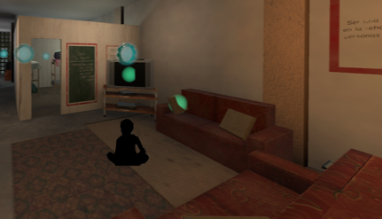

|  |  |
| --- | --- |
| **Scene/space:**  Living room, the kid sitting over the mat on the floor facing the tv.  **Lighting:** Normal incandescent light 3500K and T.V. fill light |  |
| **Character and action:**  Kid sitting, watching the tv. with simple movements, he looks shy and uncomfortable. Small head and hand movements, that can be looped. |
| **Actor direction:**  The kid is sitting with crossed legs, watching tv., his hands, and to his left in direction to the bedroom door. He’s in a place he doesn’t know trying to relax but unsuited. Staring at his hands first before switching to stare at the tv (10 sec.), to his left at the door (3 sec.). |
| **Sound:**  Background of the T.V. / white noise on a low volume/ the far noise of the cars in the street/ kitchen electrodomestics noise. | |
| **Why:**  Positioning the child sitting on the floor will create this absence of belonging, his interaction and behavior in a new and unknown place. This shows the innocence of kids when they are in a different environment which they are not used to; the simplicity of just being on the floor no matter how uncomfortable even though there is a couch it is not catchy enough for the kid to go and sit there. For the lightning, it is needed in the space general light, so incandescent light will be the perfect type to give a familiar place but not too warm for the user to see it properly; and the t.v. light to show it is on. Also, the movements are simple so as not to alter the resolution of the characters with rough movements; besides, the kid is drawn to the T.V. watching attentively, so no movements are really necessary but we wanted to implement a simple one to give him “life”. Finally, the ambient sounds that we choose are going to be the noise of the T.V., and just background noise called “white noise”, which will just fill the rest of the normal noises in real life. | |

**Storyboard Interaction #1**

*Characters appear with the interaction of the user with the cushion.*

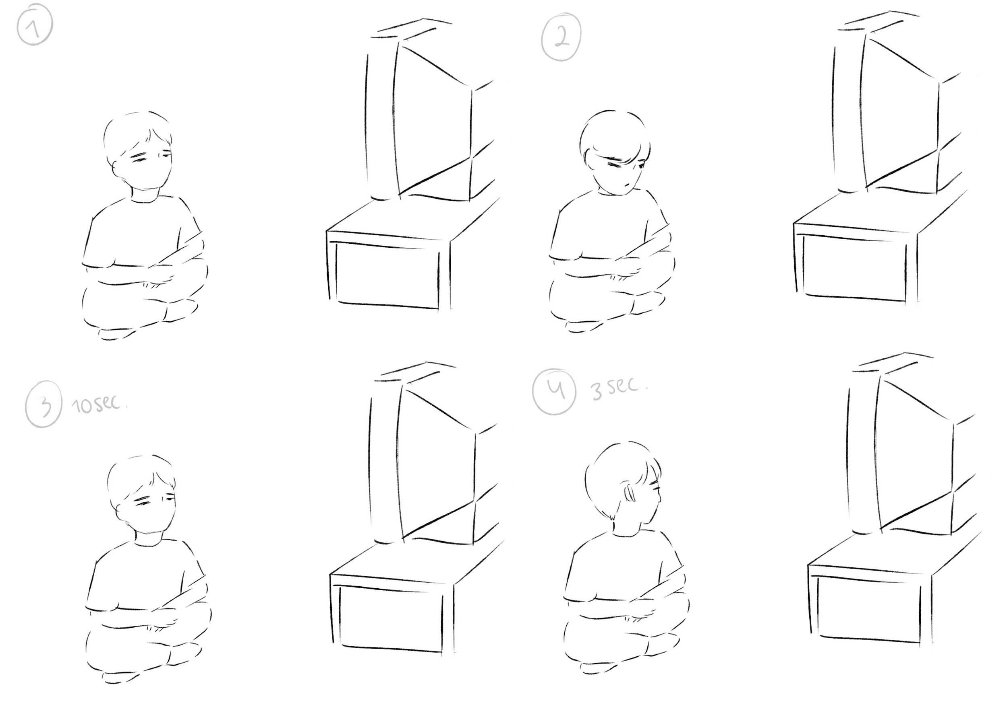

***Interaction #2:*** *Characters appear after the interaction with the fruit in the counter.*

|  |  |
| --- | --- |
| **Scene/space:**  Woman looking/searching for a glass to give her son lemonade.  **Lighting:** Neutral Light 5,000K |  |
| **Character and action:**  Looking at the kitchen counters, small moves with her feet, moving her head side to side and her hand to her chin(slowly), looking for the glass. (15 sec of total movements, to be looped) |
| **Actor direction:**  The woman looks in a hurry trying to find a glass but overwhelmed by the amount of things around with no apparent place. She does small uncertain moves and her gaze seems to study the counters. (15 sec. loop without audio) | |
| **Sound:**  Kitchen electrodomestic noise/ Kid in the background “Mami tengo sed, ¡quiero limonada!” / woman looking in the kitchen “Si hijo, estoy buscando un vaso! Hay muchas cosas… a ver”/ far noise of the cars and people in the street/ small footsteps | |
| **Why:**  Locating the woman in the kitchen at the current space will show the struggle of finding a kitchen artefact, as also demonstrating the lack of space for an area that requires it; the messiness of the place and the confusion of the woman trying to find something in a place she has never been. The scenario refers to a domestic scene in a place that is yet unknown. For the movements, even though they are simple moves like head and arms, they need to be at a natural/ slow speed to not interfere with the distortion of the volumetric. The lightning will be neutral light because it is needed in the kitchen for the activities carried out in this area, so 5,000K will be the perfect tone so it is not too warm or too cold. | |

**Storyboard Interaction #2**

*Characters appear after the interaction with the fruit in the counter.*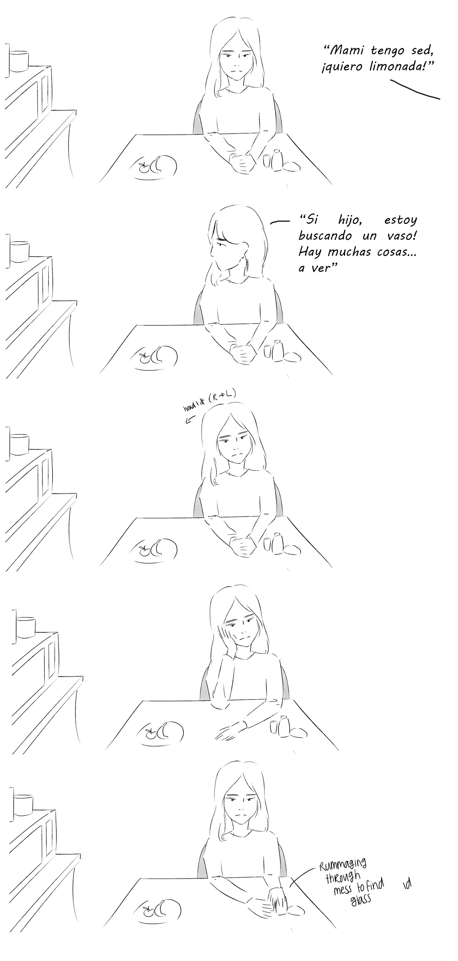

**Ideal Space**

***Interaction #3:*** *Characters appear after the interaction where the user pours water in a glass.*

|  |  |
| --- | --- |
| **Scene/space:**  Woman will be sitting on the couch reading the newspaper while the child will be playing in the child's corner.  **Lighting:** Normal incandescent light 3500K |  |
| **Character and action:**  Woman will be sitting in the corner of the couch, close to the kids corner, she’s covering her face holding up the newspaper and when the kid talks she will lay it on her lap turning her head to the right to see her kid (4 sec). Meanwhile the kid will be playing with the interaction area (lego wall) on his knees, then he will turn his head looking up towards his mom. |
| **Actor direction:**  The kid is comfortably playing, distracted. The mother is reading the newspaper, without moving the pages, slightly moving the head to follow the reading. The kid calls the mother “Mami mami, mira” the mother lowers the newspaper and nods while smiling (10 sec. kid playing + woman reading, then, woman lowering newspaper) | |
| **Sound:**  The movement of the newspaper/ the kid will be the only one talking, calling out his mom for her to see how he is playing: “Mamá, mamá! Mira!”. He will say this when he turns his head around facing his mom. | |
| **Why:**  We wanted to join both characters to show a moment of bonding between them as a family. The woman will be reading the newspaper as it is a common activity migrant women do in their free time to feel calm and rest, sitting on the couch feeling comfortable with the new furniture of the new design; for the child he will be playing and interacting with the lego wall, toys that will be catchy and entraining for him maybe new, interacting with the new design. The movements will be a little bit more elaborate and will take more time as it is a longer interaction. As for the lightning, it will be the same as the current space living room, normal incandescent light not too warm so the kid can see what he is doing, same as for the women so she can see what she is reading. For the sound, there will be a simple and short dialogue showing the energy of the kid and the attention a normal kid needs from their parents. | |

**Storyboard Interaction #3**

*Characters appear after the interaction where the user pours water in a glass.*

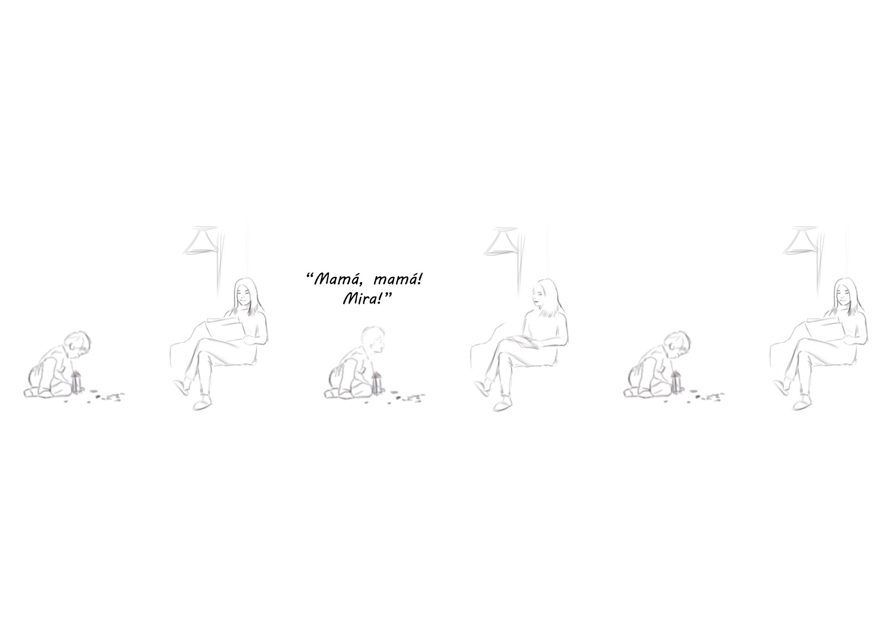

***Interaction #4:*** *Characters appear with the interaction with the rosary.*

|  |  |
| --- | --- |
| **Space:**  The woman and the child are in the bedroom. The woman is praying sitting on the bed and the child is laying on the bed.  **Lighting:** Dim light 2,000K orange-y tone |  |
| **Character and action:**  The woman is sitting on the bed with folded hands facing towards the altar that is in the bedroom.  The kid is in the bed facing the small altar and candles. He is sitting in the bed looking at a book. |
| **Actor direction:**  The woman is thankful because her son and her have a safe shelter where to stay. Her movements are natural, she is leaning her head like an act of respect and devotion. The kid is in bed, legs crossed and looking at a book, he then moves to lay down on his chest to be more comfortable reading. (45 sec. kid looking at the book + woman saying her praying) | |
| **Sound:**  Kid breathing, kid mumbling as he reads/ The sound of the bed when he moves position/ The sound of the pages as he reads/ The sound of the woman’s voice is calmed, almost like a whisper.  “Gracias Dios mío por ser nuestra guía en los momentos difíciles, por ponernos frente a personas amables que nos dieron alimento y techo para dormir, por haber tocado el corazón de los polleros que nos tuvieron hincados y por poner en nuestro camino a María la mujer que nos habló de esta casa, que se haga tu voluntad” | |
| **Why:**  All of the women believe in God, these interactions will show their culture, their faith, strength, their reason and motivation to keep going through the journey. As well, the intention is to join both characters to show their unity and bond as a family. Both characters will be in this interaction to show this important moment for them that reflects the generality of migrant women beliefs, culture, faith, religion, etc. Movements will be really simple, just the woman slowly moving her head up and down, staying for a few seconds making this reference they do to God. The light will be 2,000K to create an intim and personal environment of respect to the prayers and their beliefs. For the sounds white noise will fill the emptiness of the room which is going to be really quiet almost as if there is no one there, along with the prayer. Also, we decided to create this interaction because one thing that represents migrant women are the prayers and their beliefs in God, their religion and faith to keep on their journey. | |

**Storyboard Interaction #4**

*Characters appear with the interaction with the rosary.*

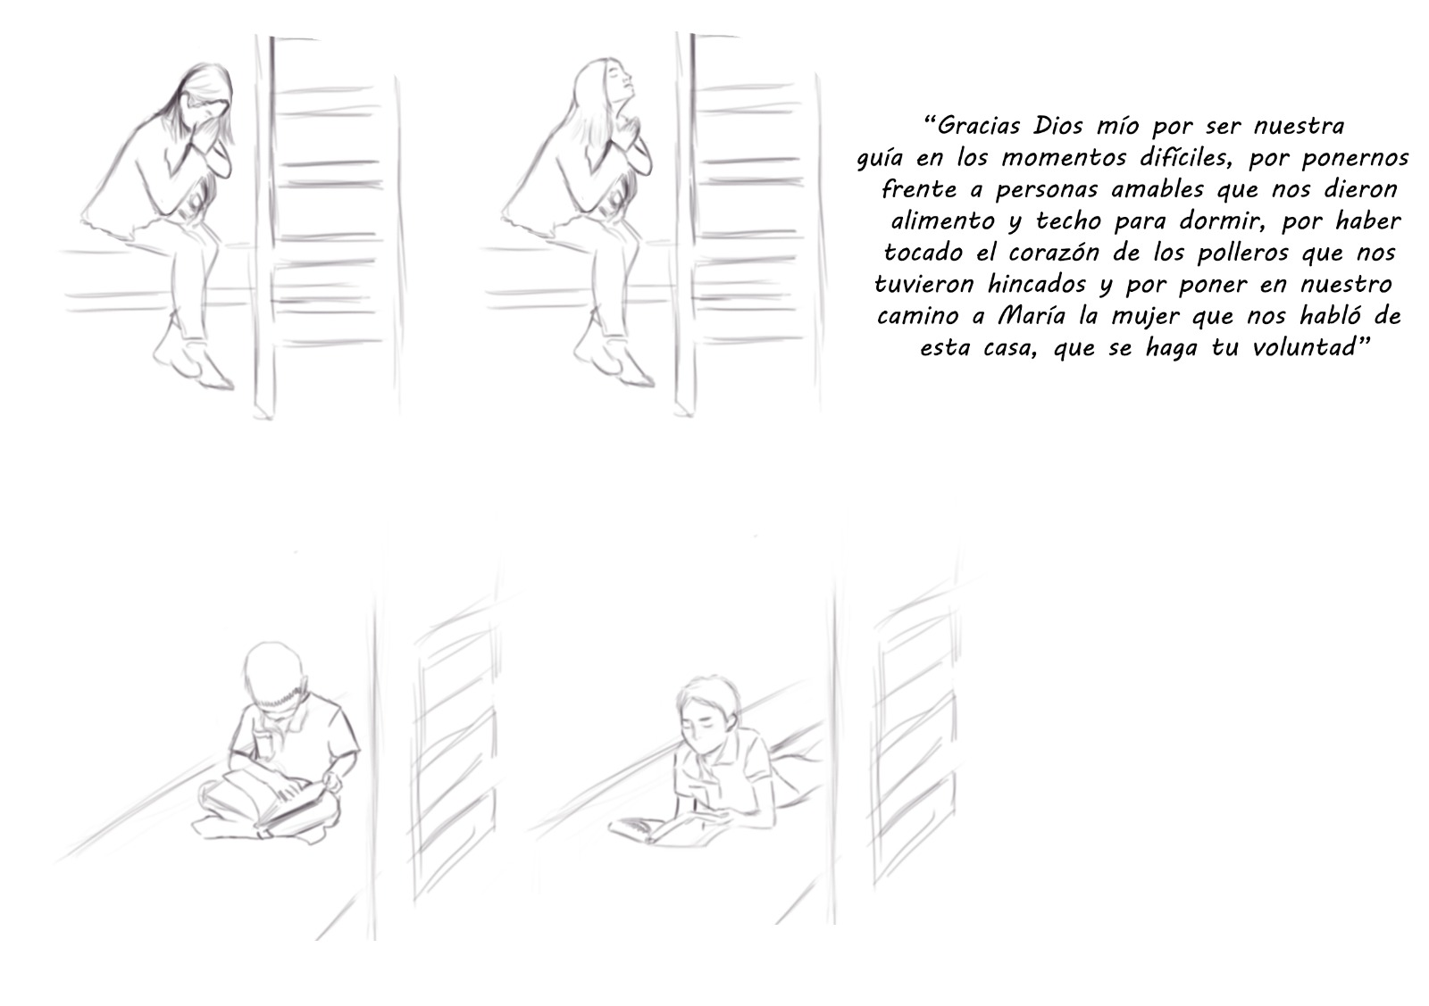

**Placements**

We have decided to use Minecraft, because it is a good way to show different scenes in a 360 environment, as Minecraft provides a 360 perspective. Moreover, Minecraft has an easy learning curve and therefore it is not difficult to build proper scenes after not spending that much time practicing to get a sense of how it works for the students. Furthermore, the scenes represent objects easily, so it is easy to see what the scenes look like (like how a kitchen, or a living room looks like), so because it is clear to see what the scenes resemble, it looks plausible for the viewer.

Link to the Minecraft storyboards:

<https://drive.google.com/file/d/1XWQKjHXOL0GAXyDHa1p0NyAn7__Gcu0s/view?usp=sharing>

**Chapter 3: In the Volumetric Studio**

**Technicalities**

In the Volumetric studio there are 8 pods, with 32 cameras in total and a big 360 green screen. We have 2 minutes to record with the actors and get the movements that are needed. This means an average of 20 seconds per action since we have 6 different actions. However, some actions can be recorded within 10 seconds, so we spare some time for the more complicated actions or retakes if needed. We recommend shooting the character all separately, since this will improve the quality of the recordings.

We recommend shooting the characters in 30 frames per second instead of 60 frames per second. We have kept the actions small and non-complicated, therefore we believe 30 fps would be enough. This will decrease the amount of data with half compared to 60 fps, making sure the VR experience is not too data heavy.

After the actions are filmed the system removes the background and creates a silhouette. With this silhouette they create a 3D-model, a so-called mesh with texture around it. They can not change anything about the recordings, they can only make the character bigger or smaller. Making the recording right is crucial.

There are many things we took in account when giving these recommendations for the volumetric characters. Volumetric Capture has a huge potential, but is admittedly still in its beginning phase, creating certain limitations. This is why we recommend not taking too many risks. For example, having the characters touch will create the risk of the 3d models melting together in certain parts. Having the characters walk from one place to another can create lagging and the risk of the user walking through the characters, ruining the illusion.

**Actors**

We would need two actors for the Volumetric Capture in the Netherlands. One woman and one young boy, both with a Latin-American background (preferably from Honduras). The woman should be between the ages of 30 and 40. The boy should be between the ages of 6 and 9. Both preferable with straight hair and more defined facial features (better for Volumetric Capture). For the wardrobe avoid white and green clothing since it will intervene with the volumetric capture as well. With subtle make-up like eyeliner the facial features will pop more of the volumetric characters.

For the child there has to be a supervisor/guide in the studio to direct the child and get the right reactions. Distracting them with television is a good method according to Steye Hallemal.

Rehearsing the actions before entering the Volumetric studio is highly recommended. Using tape or sounds are also recommended to direct the actors in the studio.

**Props and measurements**

To keep into consideration the recordings of the volumetric characters interactions it’s important to consider the following list of measurements that are key to keep in mind while capturing.

*Current space*

Measurement from the kitchen island and the counter, also the measurements of the pile of dishes and cups.

* Distance between the counter and the kitchen island: **1.01M**
* Measurement of the pile of dishes and cups: **0.36M**
* Measurements of the pile of cups above the pot: **0.46M**

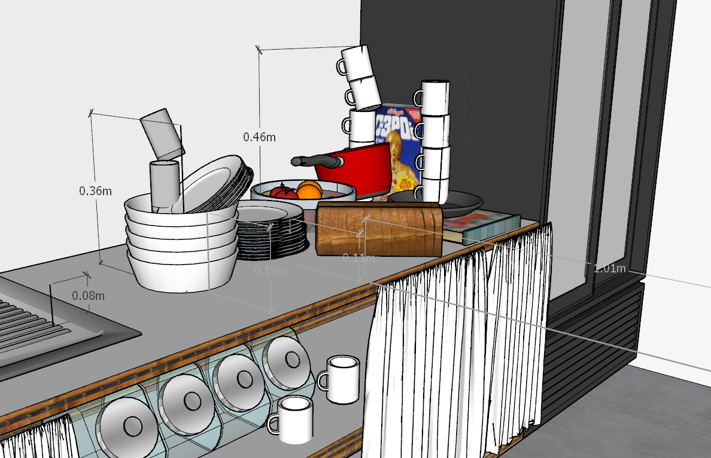

Measurement of the distance between the kid (the circle is where the kid is supposed to be) to the couch: **1.19M**

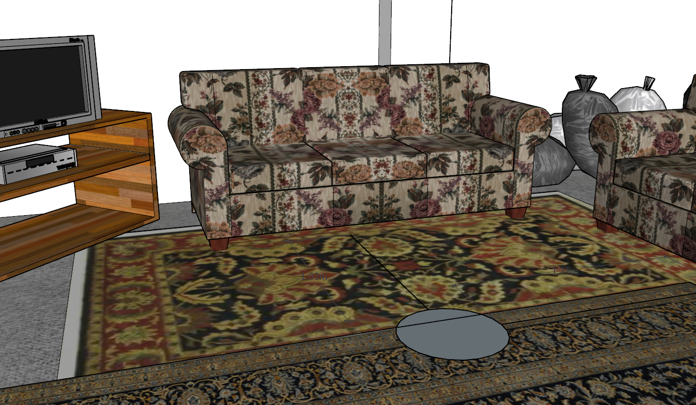

*Ideal Space*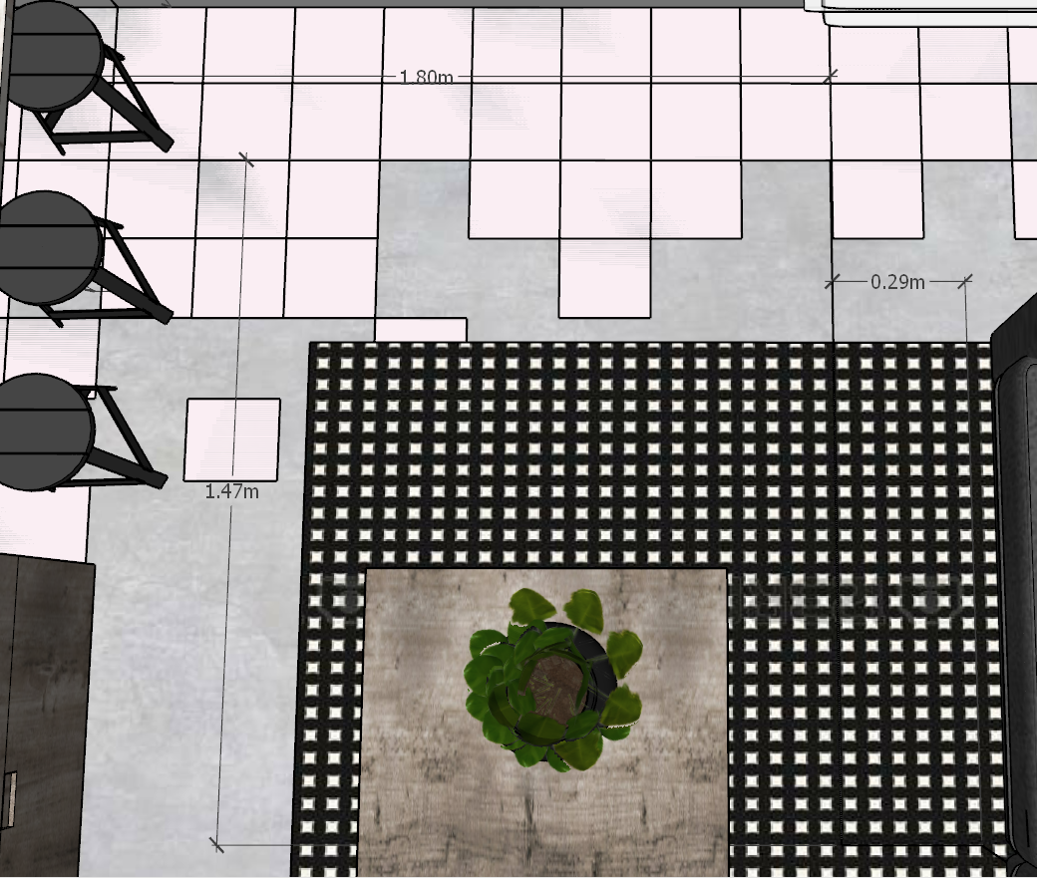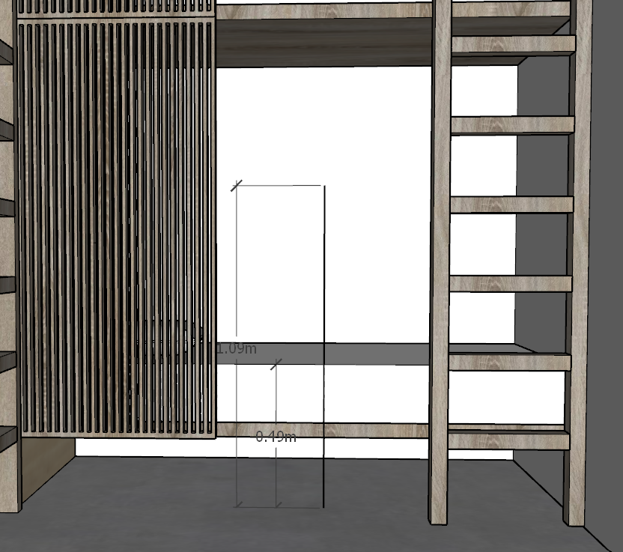

Measurement from the person to the floor, sitting from the bed.

* Distance between the bed and the floor: **0.49M**
* Distance from the floor and an average person sitting on the bed: **1.09M**

Measurement from the couch and the studio for the kids: **1.80M**

Measurement of between the floor and the top of the bench: **0.35M**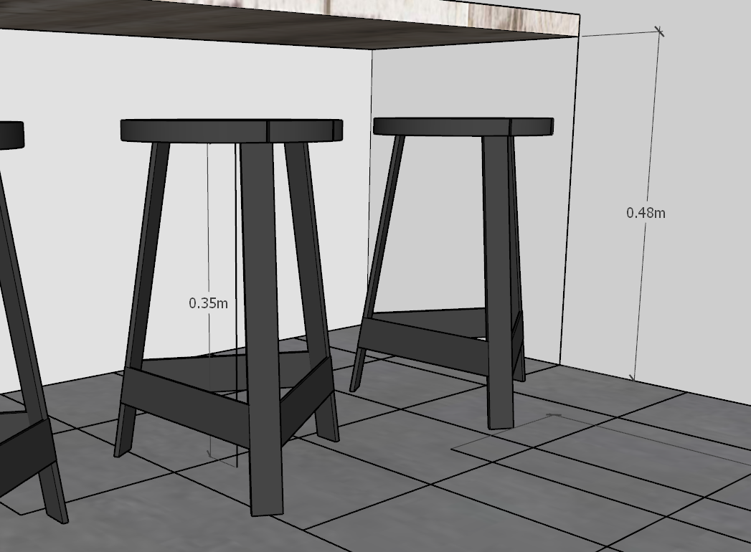

**Chapter 4: Sound design**

**Research**

With the usage of Volumetric Capture “A user can interact with the cameras that were used to record scenes and they can hear spatial sound in the space as it was recorded.” And you will also have “the opportunity to hear the directionality of sounded doings.“ (McIlvenny, 2020)

**Ambient sounds**

In the current space, you will hear **background sounds of a Television** in the living room. There will also be a **white noises** on a low volume. And there will be **far noises of cars and people** on the streets. Furthermore, you can hear **electrodomestics noises** in the kitchen. You will also hear **sounds of the mom wrapping up** **a newspaper** after she reads it. Next to that, you can hear **small footsteps** when the mom heads over to the kitchen counter. There will be sounds of the **user pouring some water** in a glass. Moreover, there will also be some sound-effects of the **child breathing.**

When changing the scenario to the ideal space the noise of the street can slightly be heard, only from the kitchen. The sound of the kitchenware is silent, as well as the rest of the house.

**Dialogue**

“Mami tengo sed, ¡quiero limonada!” / woman looking in the kitchen “Si hijo, estoy buscando un vaso! Hay muchas cosas… a ver”

The child will be the only one talking. He is calling out his mom for her to see how he is playing: “Mamá, mamá. ¡Mira!”

The sound of the woman’s voice is calm, it is almost like a whisper.

“Gracias Dios mío por ser nuestra guía en los momentos difíciles, por ponernos frente a personas amables que nos dieron alimento y techo para dormir, por haber tocado el corazón de los polleros que nos tuvieron hincados y por poner en nuestro camino a María la mujer que nos habló de esta casa, que se haga tu voluntad”

**Conclusion & Recommendations**

So to sum it up, we recommend volumetric capture in order to increase empathy and the perception of space in the VR museum. Since Volumetric capturing can place the user in a certain space and give him the possibility to freely move around and discover the universe, the level of interaction between the environment and user is much higher and more realistic. Therefore, a sense of realism and empathy is created. This added value of creating a better understanding through showing more is used in the mentioned project to achieve the goal of the user emphasizing immigrant women and finally the cause of action. We recommend two volumetric characters, a woman and a little boy, from our research these characters are the most authentic and will create the most empathy. There will be six simple interactions, two in the current space and four in the ideal space. By keeping the actions simple, but meaningful, it will not only be effective, but also technically doable and realistic. Interacting with the user, can literally place the user in the VR museum, in volumetric capturing you can go around it which you cannot do in 360 which could also be helpful in creating empathy. It will not overwhelm the user or make the museum too crowded or chaotic. Instead we hope it will create a welcoming experience where the user has time to think and realize the reality of these immigrant women and therefore create more empathy.

To conclude we want to say that this has been such a special project to work on, not only because of the amazing cause and goals of the project, but also because of the international collaboration between our two universities UDEM and BUAS. Not only did we as a team communicate well and learn from each other, but we’ve also made some friendships along the way. In addition we got to learn about Volumetric Capturing, a new and futuristic technology, that not many people have got to work with. We are really happy and grateful to be able to contribute a small piece to this project and hopefully help these immigrant women to receive more awareness and empathy by people all over the world.

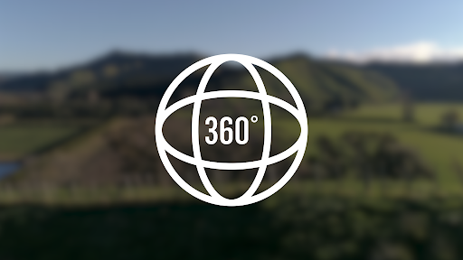

Project: Being There

360 Video and Storyboard document

Collaboration by UDEM & BUAS

# Introduction & 360 Videos

360 video is a recording in all directions, giving the user a complete 360-degree view. While watching these videos, the user is in control of what they see. These types of videos are recorded with a special camera or by creating different footage at the same time. It allows the user the capability of choosing what they see and give to the whole experience a different feeling of being there, by allowing the user see the actual places or situations and create this bond and empathy with the situation of immigrant women and having a better idea of the space. In addition to the VR experience, which has digital images, a 360 video gives the user a more realistic vision, because he is in control of which direction “the eyes'' are focused on.

**Why 360 Videos?**

360 degree videos offer a unique experience in that, as the name would suggest, you see everything around you: a full 360 degrees. It effectively transports the viewer to a different "world", without the limits of a flat, 2D environment. Because of the levels of immersion one can create through these types of videos, as well as immersion being a key point in creating empathy and understanding in the viewer, we opted for 360 videos over 2D. In addition to theVR experience, a 360 video gives a reality of the space and situations immigrant women have to live and experiment through the journey.

# Storyboard Methods

To briefly explain storyboards, the name is kind of self-explanatory in that storyboards are essentially the story but boarded out: to be able to see what kind of shot goes where at a single glance. To create storyboards for the 360 degree videos, we use two different storyboard methods. We start by creating digitally drawn storyboards, using those as foundation for the storyboards we will create in Minecraft.

**Digitally drawn storyboards**

Compared to drawing storyboards traditionally, creating these digitally allows for quick and easy fixes. When drawing traditionally, an eraser can only get you so far. But when drawing digitally, one can use shortcuts and built-in features such as “transform” (allows the user to transform the layer/image in any way they would like, e.g. changing width, height, etc.) and “undo/redo” (to undo a previous action taken or redo it). The digitally drawn storyboards are used as a base for the Minecraft storyboards, so that those working on that have a better idea of what needs to be present in the environment. Additionally, both printed and kept as a digital file, these digitally drawn storyboards will be easier to bring to the actual shoot of the 360 video(s).

The storyboards will show two possible views of the 360 environment, a front and a back view, showing the environment from the eyes of the visitor. Additionally, the environment will be indicated in a simple manner.

**Minecraft storyboards**

While Minecraft is, first and foremost, a game, it offers a 360 environment with options for free-building, which allows it to be used for 360 degree storyboards as well. It is not free, the program costs 23,95 euros, and the server we use costs 5 euros a month (the pricing of the server depends on the amount of storage). The main reason why we chose Minecraft, is that the program has a low learning curve, offers a lot of building options, gives a clear image of the scene (simple overview: this way you do not have to leave certain things up to imagination. E.g.: how will the viewer see this? Where do I, as the viewer, stand in a scene and what does this look like?) as well as it being widely available in multiple languages. An added bonus was that some of us were already familiar with the program as well. Using Minecraft in addition to the digitally drawn storyboards makes it so that the storyboards are as clear as possible.

1st and 2nd scenario will be presented as a small compilation, both talk about dangerous scenarios women face in their journey, it’s intended to be watched in the store of the built space this created the contrast of what’s in the outside world with what the shelter has to offer.

# 1st 360 Scenario - Male Intimidation

**Research**

Sexual assault by men is a huge danger for immigrant women during their journey. According to the Executive Secretary of Mexico’s National System for Public Security (SESNSP), during the first semester of 2019, 25,277 investigation files related to these offenses have been opened,in the first half of the current year, the most reported offenses were sexual abuse, with 11,691 cases; rape, with 6,594 cases; other unspecified offenses, with 2,382 cases; sexual harassment, with 1,978; equivalent of rape, with 1,870 cases; and incest with 17. (El Universal, 2019)

**Scenario**

In this scenario you are the immigrant woman being forced to walk through a sketchy alleyway at night. A scary looking man walks straight past you, eying you up and down with a smirk. He then walks away and the experience ends.

**Justification**

In this 360 mini experience we want the user to experience an uncomfortable situation without being too graphic or triggering. Showing this uncomfortable feeling is extremely powerful and only recreatable in Virtual Reality. Seeing this man walking up to you in a dark alleyway will for many women be an incredibly recognizable situation and fear. However for men it’s a bit more difficult to activate the flight or fight instinct in this scenario. By making the men stand close to you and eye you up and down, there’s a higher chance of activating the uncomfortable feeling. This scenario will hopefully bring more awareness and empathy for male intimidation.

**Video Length**

15 seconds.

**COVID-19**

Possible to film with COVID-19 regulations.

**Actors**

This scenario only requires one male actor. The actor should be Mexican between the ages of 30 and 40 years old, wearing normal street-clothes.

**Equipment and Props**

The equipment and props needed are as follows:

|  |  |
| --- | --- |
| **Equipment** | **Props** |
| 360 camera | Something to hide the crew behind. |
| Microphone |  |

**Sound Design**

For sounds, we’ll play with the uncomfortable feeling of a quiet alleyway. The only sounds are ambient sounds like cars passing by. For the man walking you’ll hear footsteps coming closer. When the man stops next to you, you hear his breathing and there will be some soft heartbeat sounds to create the tension. The man turns back and walks away.

**Storyboard**

Front view Back view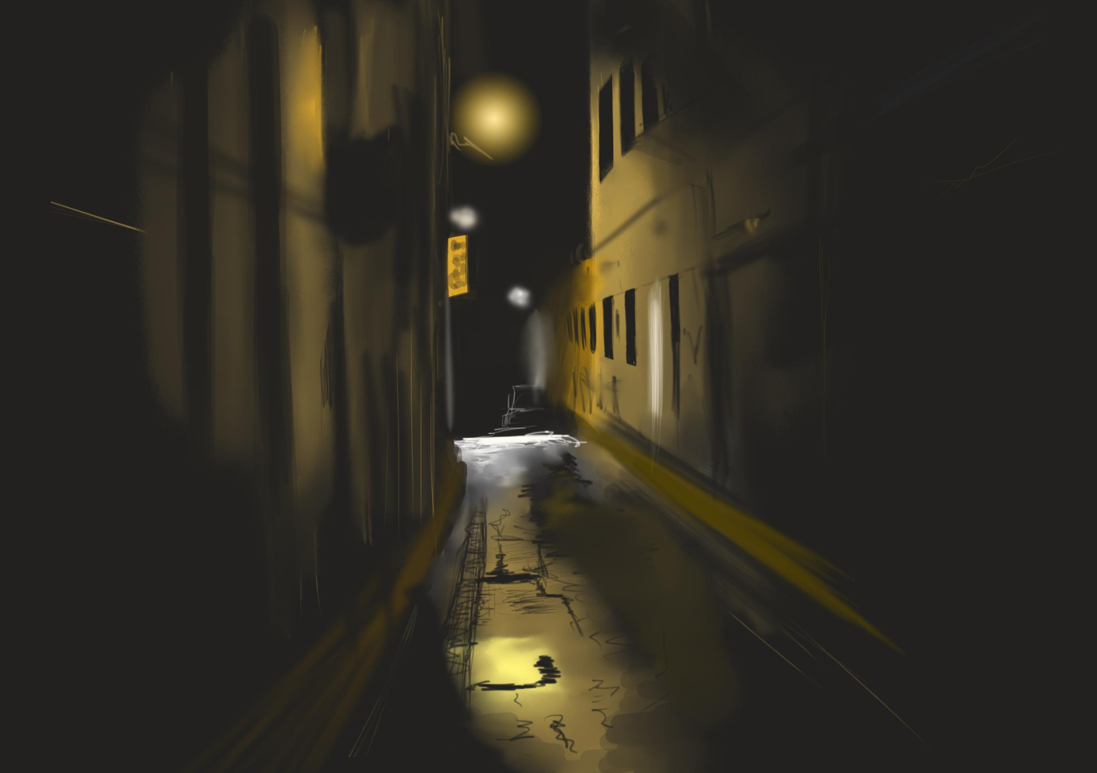

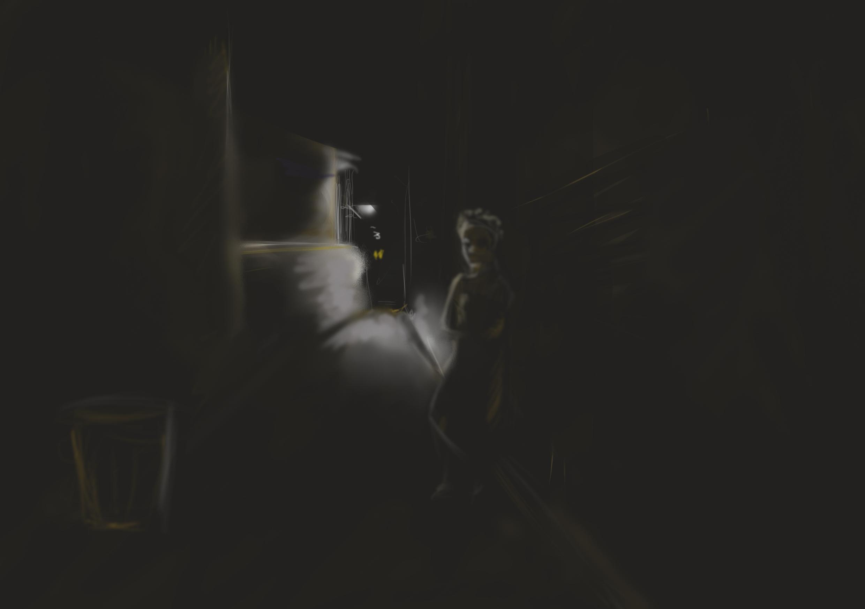

# Overview

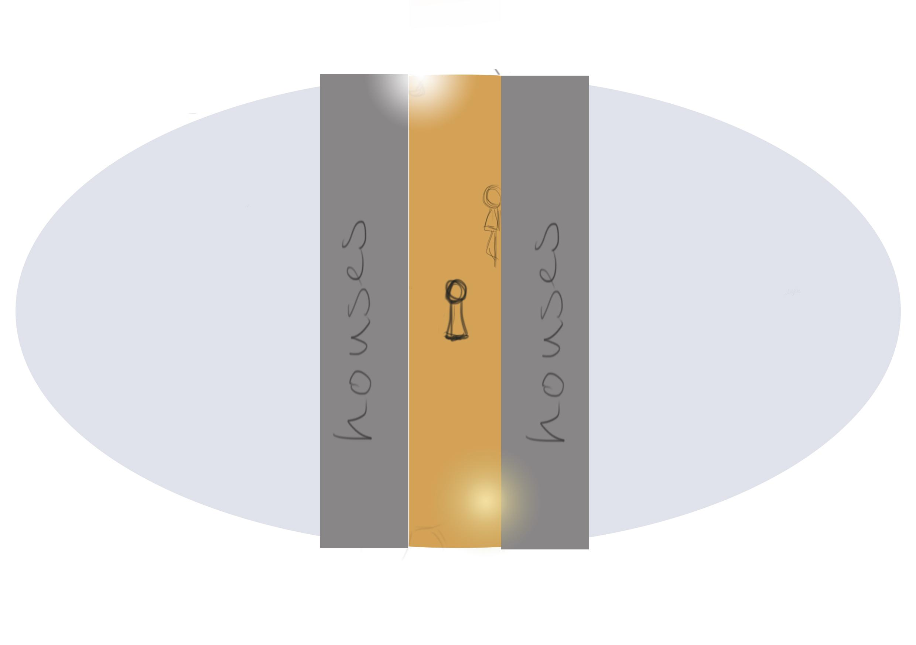

# 

# 2nd 360 Scenario - Kidnapping in the desert

**Research**

The potential of being kidnapped as an immigrant woman happens often, and sure is a big hazard when the immigrant women are on a journey with the goal to survive. In Mexico the insecurity for women is one of the highest in the world, despite the fact of being immigrants or not, in 2019 the public perception of violence was 78.7% (CNNl, 2020). At March 2020, the record of 26,171 call of emergency about violence against women.

**Scenario**

In this scenario the user is walking on a road without ending on both sides. The environment looks warm and dry, it’s desert-like and it is the beginning of the sun going down. There will also be sounds of coyotes in the background which can be heard at the beginning of the scene, but you don’t see them. After hearing the sounds of coyotes you will be walking through a side-alley where you can hear background noises of men yelling, and then a man sees you, runs up to you and proceeds to grab you and put his hand on your mouth and carries you to a car and kidnaps you. He will put you in a car and then you can see the door of the car being closed, and just when you can see the door of the car being closed you also hear the sound of a closing car sliding door sound at the end of the scene at the same time and then the scene will be turned in black and ends.

**Justification**

In this 360 mini experience we want to create a situation where a lot of stress is being created for the user without being too graphic or triggering. We want to show that walking around as an immigrant woman around the deserts of Mexico can be anxious, as well as being very dangerous. It can suddenly be the case that a man runs up to you and kidnaps you. This shows that a journey for immigrant women in order to survive is rather tricky, and therefore more awareness and empathy has to be created for them. With the usage of Virtual Reality we want to enhance the realism of this journey and achieve the goals of creating awareness and empathy by the user for the immigrant women

**Video Length**

15 seconds.

**COVID-19:**

In general it is possible to film this within the COVID-19 regulations, however the kidnapping part will probably require physical contact which is violating the COVID-19 regulations.

**Actors:**

This scenario requires only 1 male actor. The male actor should be a Mexican between 30 and 40 years old, and he wears normal clothing.

**Equipment & Props**

|  |  |
| --- | --- |
| **Equipment** | **Props** |
| 360 camera | Car |
| Microphone | Something to hide the crew behind. |

**Sound design**

To decide the atmosphere with the usage of sounds, we decide to create a rather nosy situation than it being quiet in this scenario. You will hear sounds of footsteps of the user, heartbeat sounds of the user, sounds of coyotes in the background. There will be background sounds of men yelling. You will hear footstep sounds of the man running up to you, and sounds when he grabs you. There will also be sounds of the car door sliding. Moreover, across the scene there will be no music being played but it is still rather noisy because of the usage of the background noises, and sounds which happen closely to the user.

**Storyboard**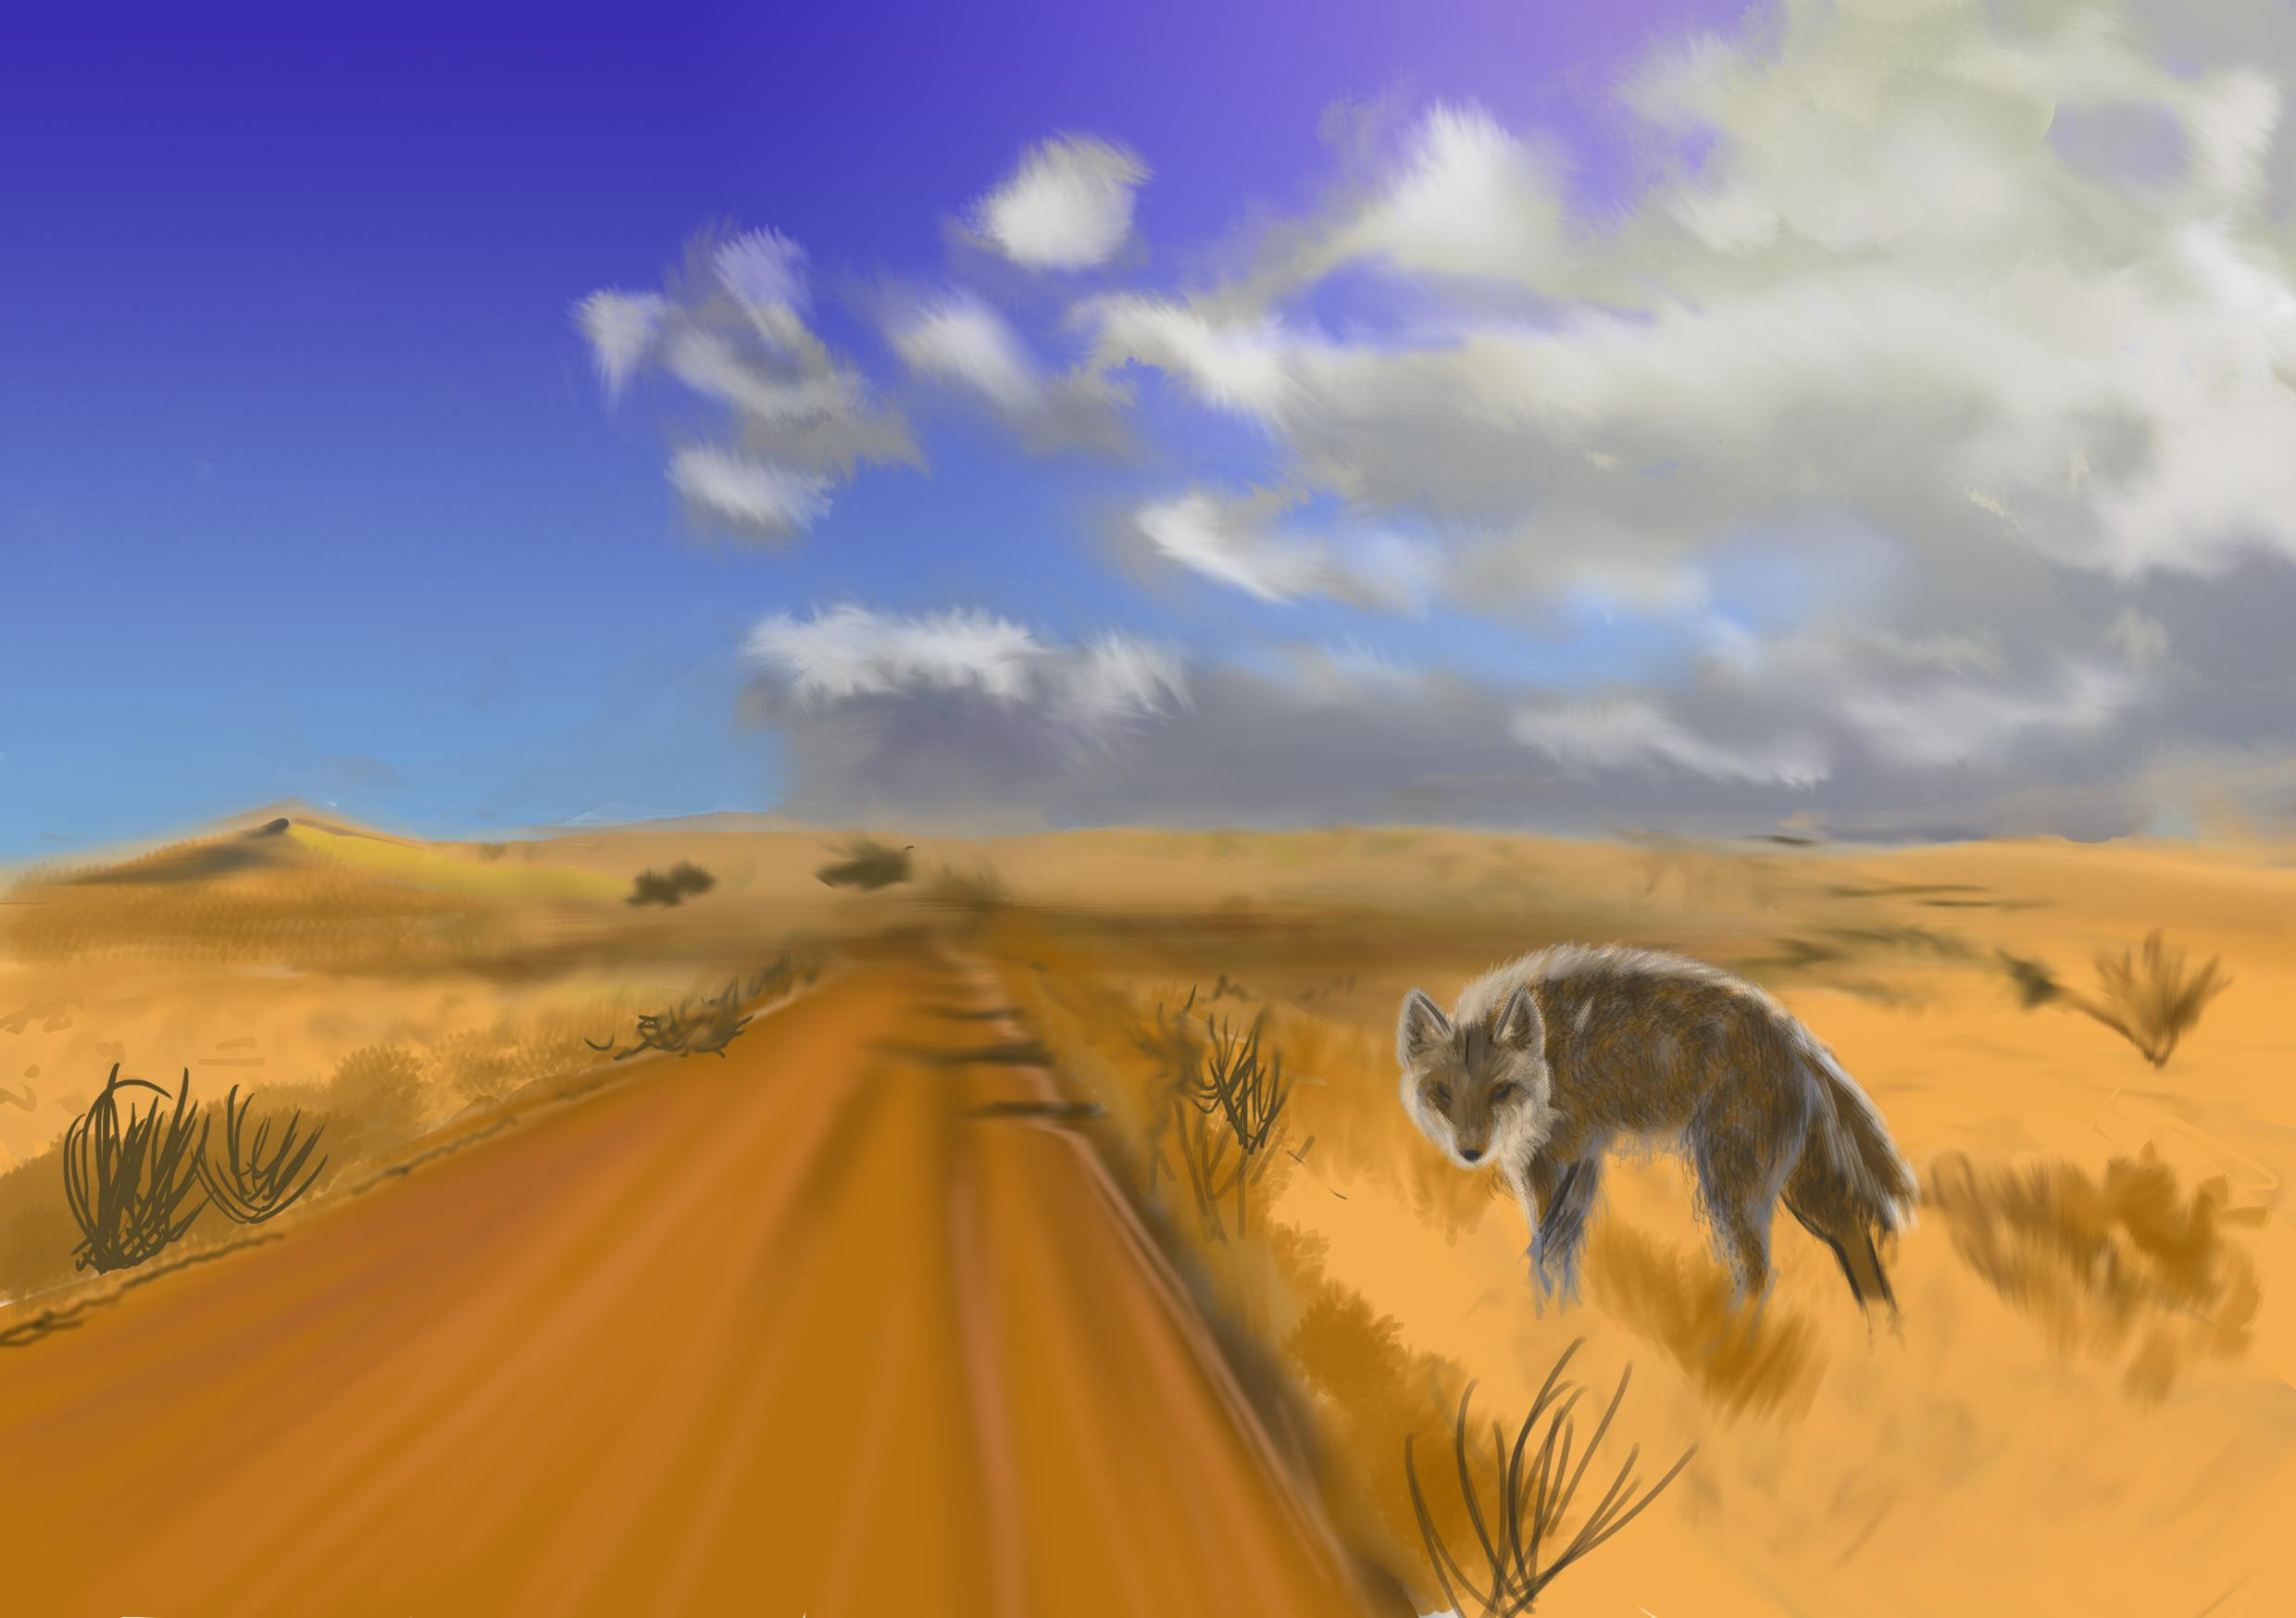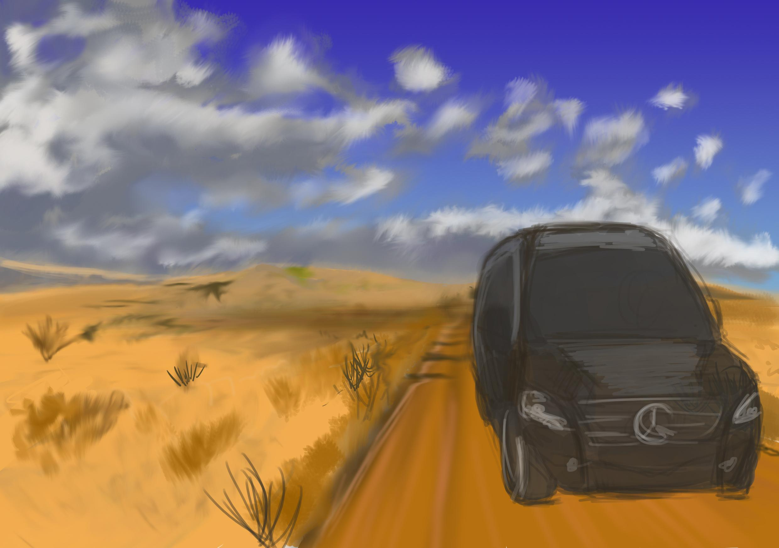

Front view Back view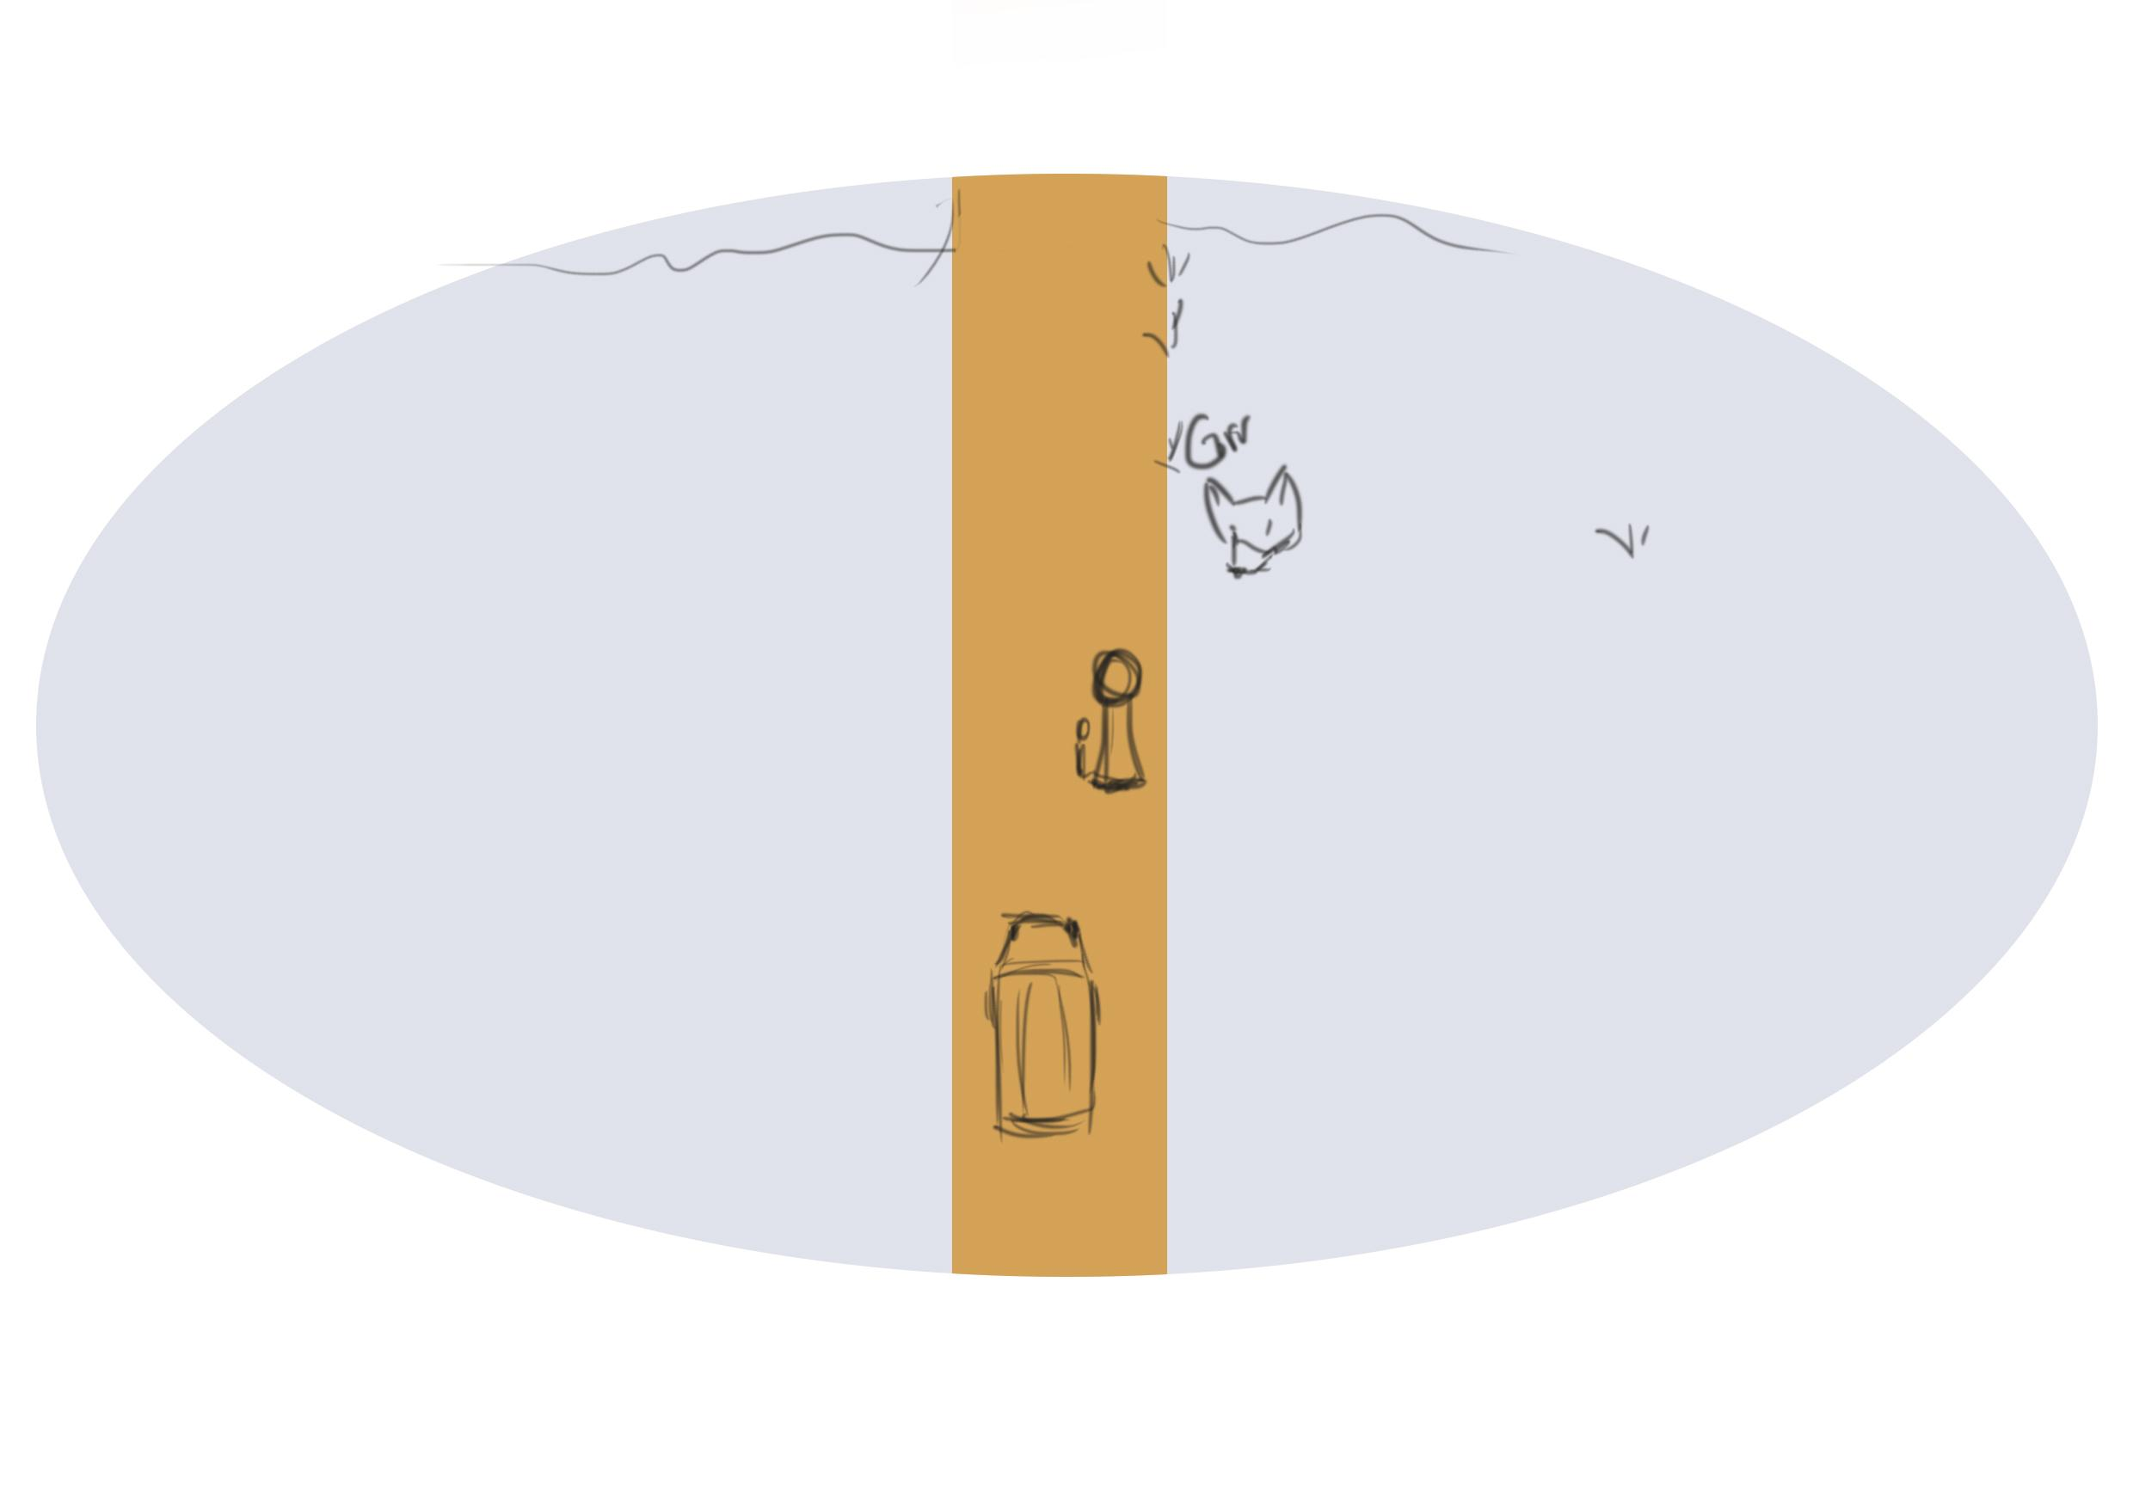

Overview

# 3rd 360 Scenario - The Immigrantion Centre

**Research and Interviews**

The concept of home is vital in this project who tries to create empathy; in the 360 video the objective is show the real living room in Lamentos Escuchados, the lack of space and intimacy women and children have; having in mind the idea of home we wanted to bring part of the testimonies immigrant women told us talking about the idea of home and space, “for me, a home is being with the people who loves you, who takes care of you, who are aware of you and that in some way they give you support, like, share their food, drink, games and talks” (Gabriela, 2020) . “The kitchen is where your own intimate life takes place, where you can be whoever you want and do whatever you want. For example, me, I can´t go to a mexican house and ask for some arepas, no, no, they don’t have that because I prepare arepa here in my house” (Gabriela, 2020).

**Scenario**

In this scenario you are standing in the middle of the real living room in Lamentos Escuchados immigrant centre, the camera is around you, you see women talk and two children run past you. It feels crowded and shows you the lack of privacy and comfort.

**Justification**

This scenario would be important for the user to understand that the VR-museum is actually based on a real place. It will also create a better understanding of space and design.

**Video Length**

15 seconds.

**COVID-19**

This scenario is not COVID-friendly to film. We would advise to film this later in the future when the regulations are less strict and safe to be with more people in one room.

**Actors**

We advise to use five adult female actors around the ages of 20 till 40. They would preferably have an Immigrant background/nationality (Honduras, El Salvador). Additionally, we would add two child actors between the ages of 7 and 15, one boy and one girl.

**Equipment and Props**

The equipment and props needed are as follows:

|  |  |
| --- | --- |
| **Equipment** | **Props** |
| 360 camera | Something to hide the crew behind. |
| Microphone |  |

**Sound Design**

The sound would be the real recording from the video. A lot of talking and two children running after each other yelling.

**Storyboard**

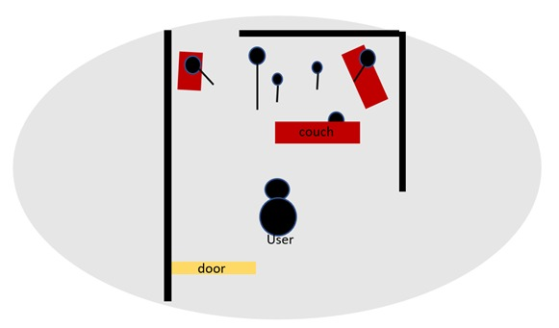

**Overview**

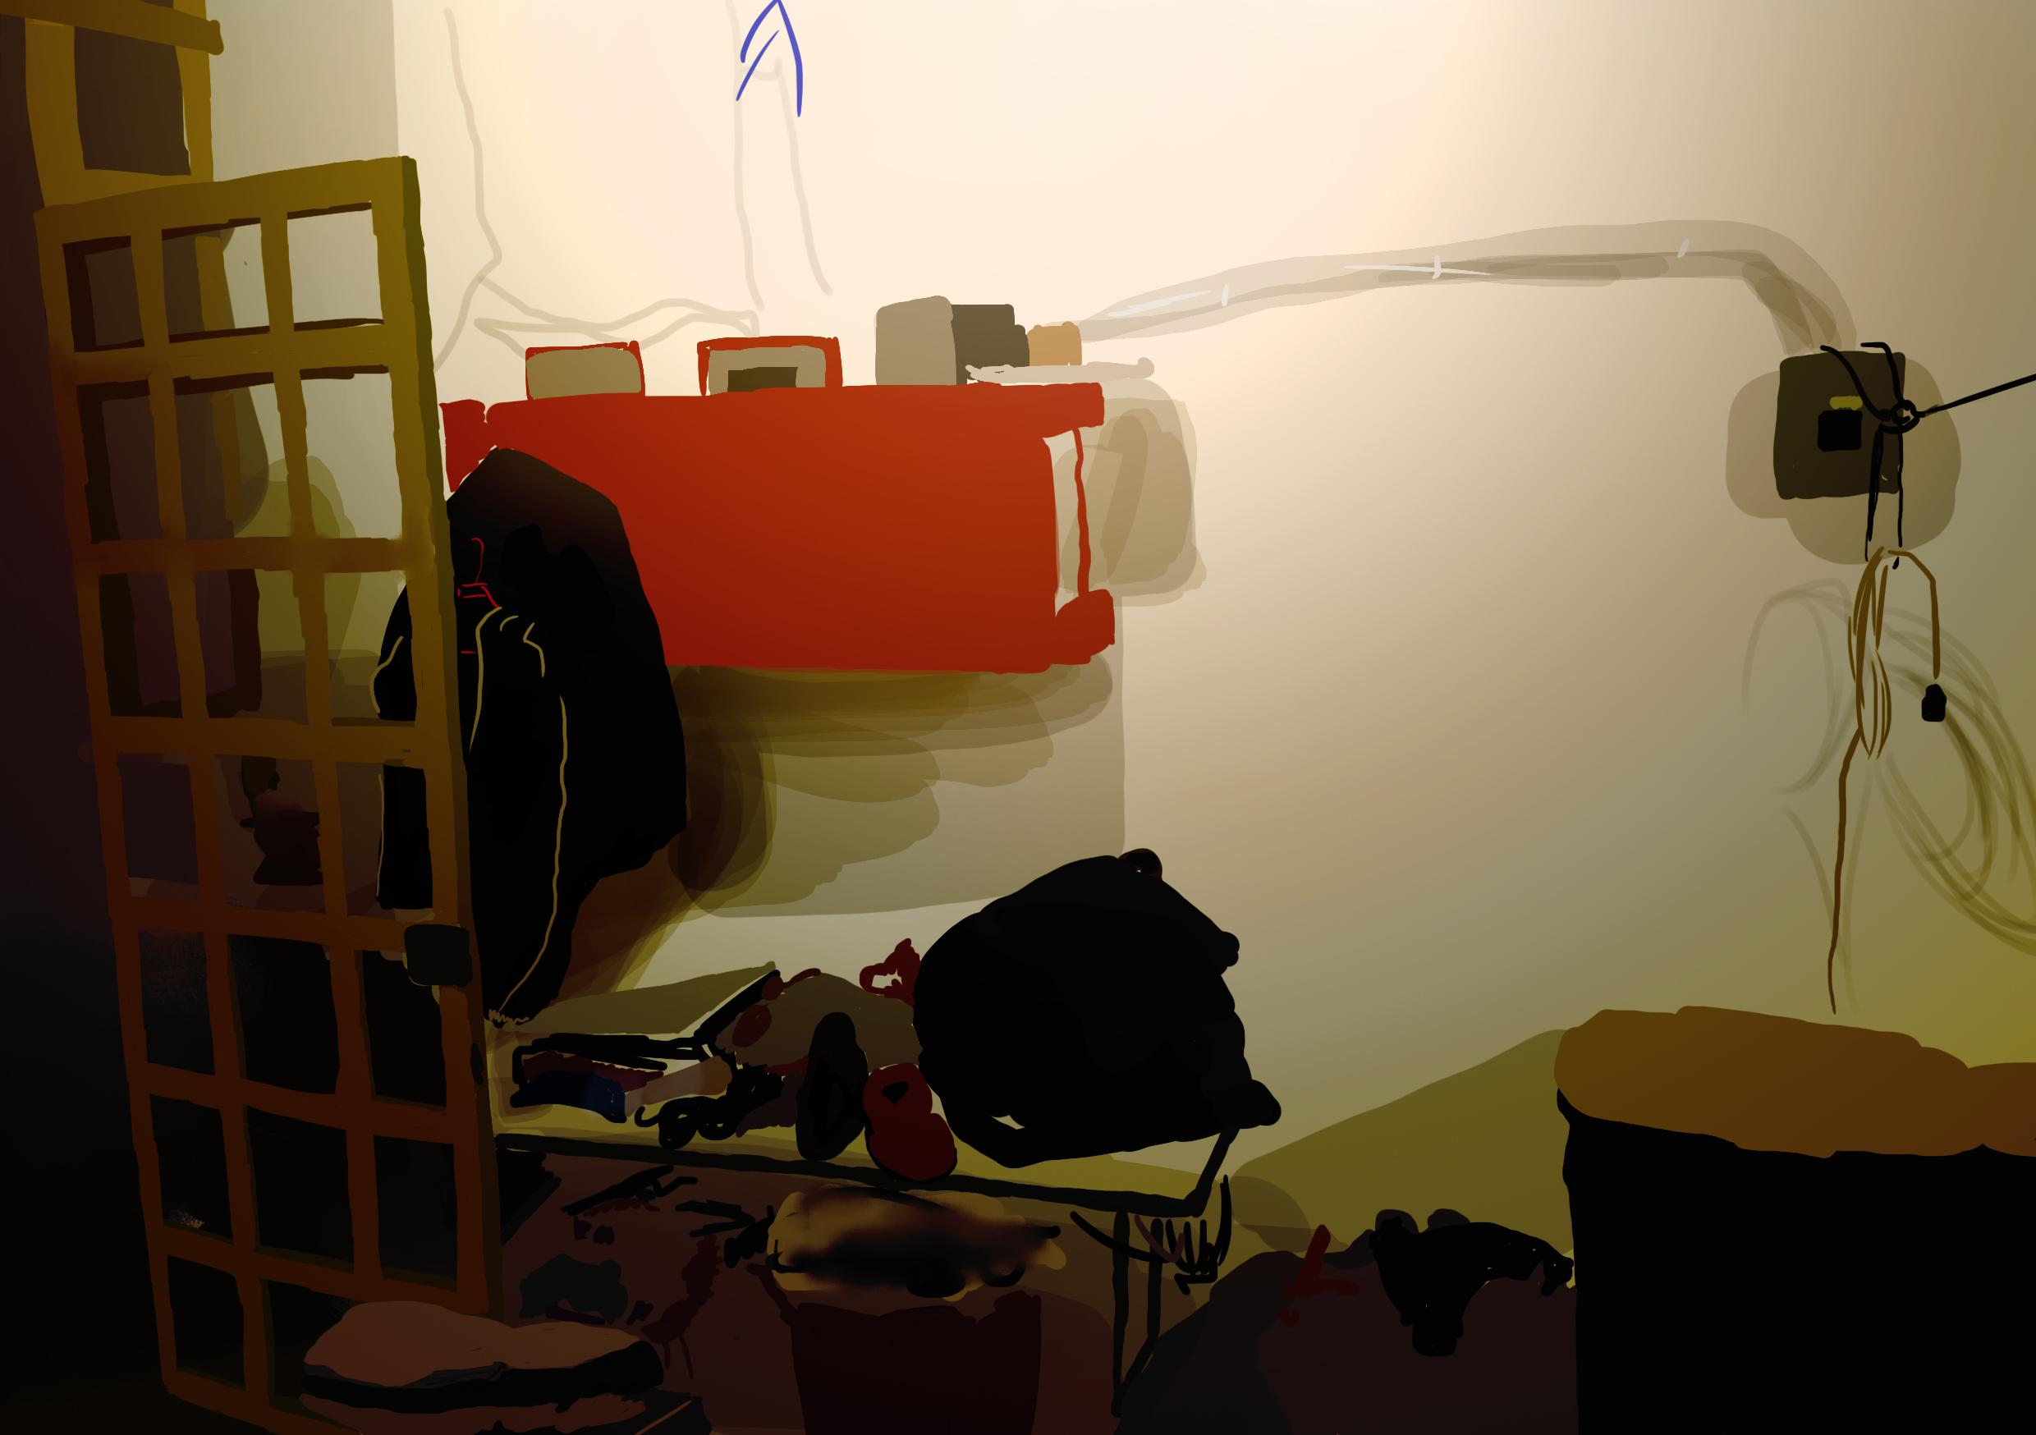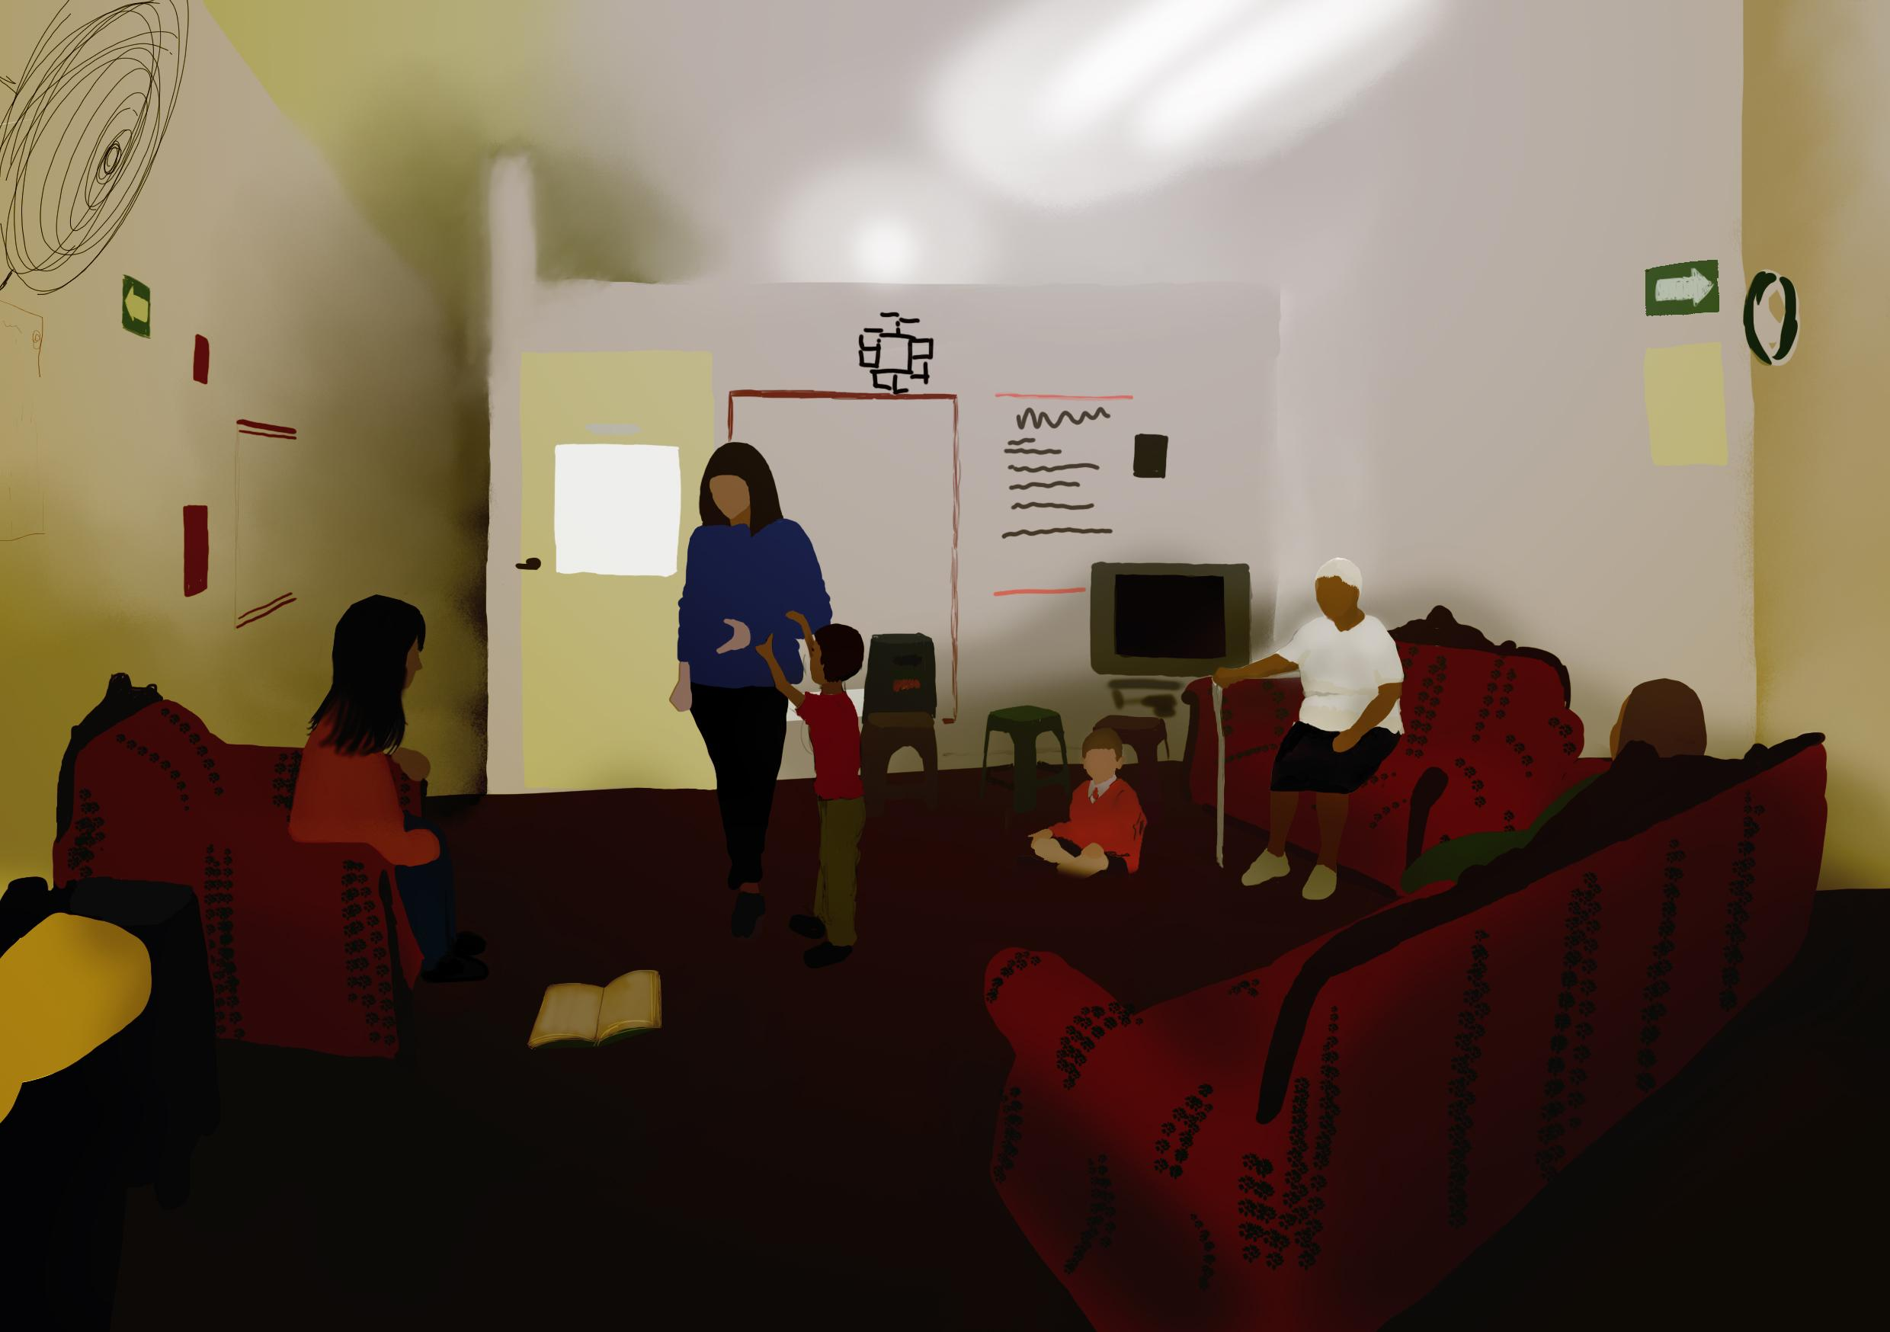

**Front view Lateral view**

**Placement in the VR-museum**

For the 360 videos, the proposals we’ve developed place the subject of the experience in the 360 camera so they are the protagonists of the situacions created. This experience provides the most popular definition of empathy because it places the subject in the experiences many migrant women live. The three recorded scenes are meant to last 15 seconds and are planned to be recorded with actors.

We developed three ideas that will be distributed as the first and second scenario in one interaction, which can be activated in the store, are dangerous scenarios that are common situations that many women go through during the immigration processes, such as harrassment, wild animals, and being kidnapped, this to demonstrate the change in surroundings, the danger from the outside and the safe feeling that being inside the shelter provides. The third scenario will be separate from the others, this works as a portal to the actual building living room, so that people can truly understand the realness of the project and see the real conditions in which the shelter is held when it holds people.

Both recordings are meant to include sound recording, this would save time and give the ultimate real ambient sound.

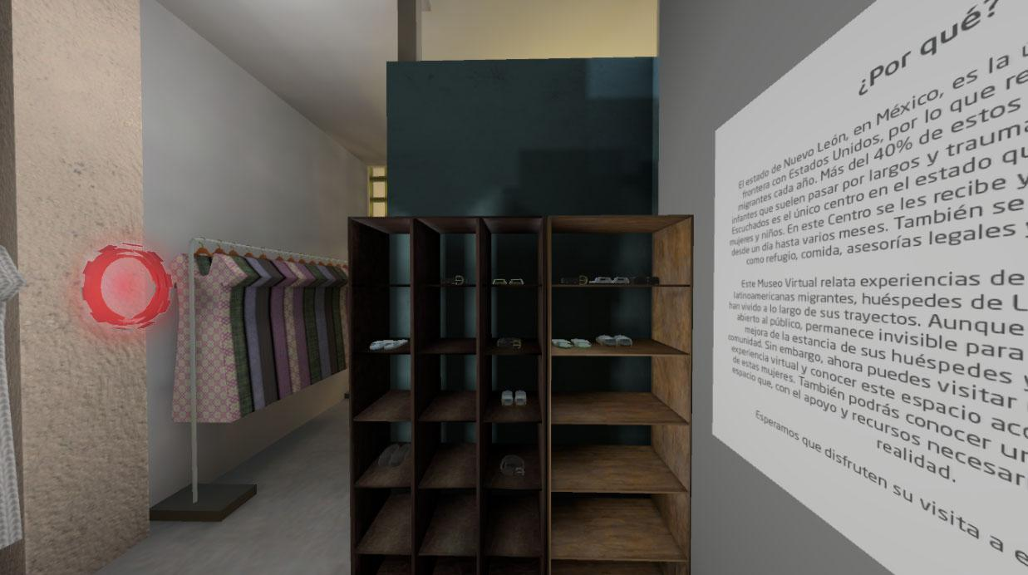

**Picture 1. *First and Second scenario*:** The red halo at the store of the current space will activate the 360.

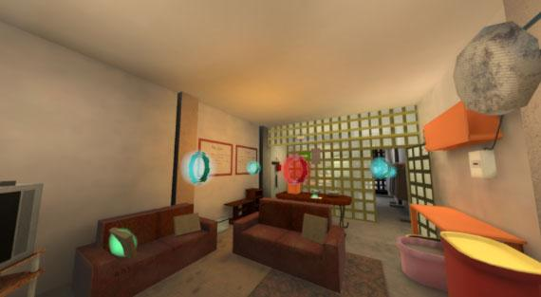

**Picture 2. *Third Scenario*: The red halo at the living room of the current space will activate the 360.**

**Risk Assessment**

|  |  |  |  |  |  |
| --- | --- | --- | --- | --- | --- |
| ID | Risk | Impact Description | Risk Score | Response | Prevention Method |
| 1 | Actors getting sick before recording due COVID-19 | Actors won’t show up which will create a delay. | Medium | Making sure that we have back-up actors. | Taking COVID-tests to see if people are sick, wearing mouth masks, cleaning hands often, staying at home. |
| 2 | Actors not showing up, cancelling before the recordings will take place | Creates a delay in the project, so that the project will take longer than expected. | Low | Making sure that we have back-up actors. | Communicating well with the actors to make sure if they’ll be there, ask about the likeliness they’ll be there, asking how they’re doing mentally and physically. |
| 3 | Recordings becoming corrupt | Not having any content at all, having to record it start all over again which causes a delay for delivering the project. | Low | Sometimes look back at the footage on the camera to see if you can actually see the files properly, check if they’re not corrupt. | Making sure to create multiple recordings, create back-ups of the recordings. |
| 4 | Unfavorable weather conditions (such as rain) | Not being able to record the scenes properly. | High | Making sure to look precisely at the weather forecast in case there will be rain. | Wait a few minutes, hours before it stops raining or plan another date to film when the weather is better. |
| 5 | Tripod and Camera damage | Not being able to record any footage at all. | Low | After the use of the tripod, put it away in a corner so that it isn’t in the walking area. | Making sure that the camera is tightly being put on the Tripod to prevent it falling on the ground. |
| 6 | Not having back-up batteries for camera | Not being able to record any footage anymore. | Low | Making sure to bring batteries along with you. | Checking out your backpack to see that you have (enough) batteries with you. |
| 7 | Filming in private or unauthorised locations | Not being able to record in these places. | Low | Make sure to do some research about these places before trying to film over there. | Asking if you are able to film in private or unauthorised places by getting in contact with the people who own the private or unauthorised locations and try to get permission granted, or try to film in a different location. |

**Conclusion & Recommendations**

In conclusion, we will use 360 and volumetric capture in order to create empathy and sense of space to the user.

The volumetric capture allows the user to interact with the character, he can orbit around the subjects, not just look at them in a static position. This generates a sense of closeness between the user and the characters which allows a better involvement in the story and how the characters evolve, especially their development between the current and the ideal space; such as how do the feelings of nostalgia, fear, etc., change between the sense of home generated in the ideal space and how it transforms from the current space.

Additionally, the 360 scenarios will portray different moments that immigrant women pass through and that are crucial for them. This will allow the user to have a different perspective of what the immigrant women experience and feel during the journey and when they arrive at the shelter; consequently, this will increase the empathy of the user by getting an experience as real as possible.

Furthermore, in order to increase empathy and perception of space in the VR museum we recommend having 1 male actor, who are between the age of 30 and 40 years old, and 5 adult women between the age of 20 and 40 years old. Based on our research, these characters with these demographics can represent these kinds of people in person and therefore it increases the plausibility for the viewer which amplifies the empathy. There will be three different scenarios taking place in the 360 experience, the first one will be a kidnapping in the desert, the second one will be a male intimidation in an alley. And the third scenario will happen in the immigration centre. We want to give the same uncomfortable feeling in every scenario to keep up with the consistency, while showing different actions to show that there are multiple situations which bother the immigrant women. In all three scenarios we want to create anxious, uncomfortable situations for the viewers so that the viewer feels what the immigrant women deal with during their journey, and we think that by showing the struggles of the immigrant women it will be an effective way to let the viewers create empathy for them.

To conclude we want to say that this has been such a special project to work on, not only because of the amazing cause and goals of the project, but also because of the international collaboration between our two universities UDEM and BUAS. Not only did we as a team communicate well and learn from each other, but we’ve also made some friendships along the way. In addition we got to learn more about 360, which is an amazing piece of technology which fits well with our goal of creating empathy. We are really happy and grateful to be able to contribute a small piece to this project and hopefully help these immigrant women to receive more awareness and empathy by people all over the world.

**APA References**

McIlvenny, P. (2020, February 22). *The future of ‘video’ in video-based qualitative research is not ‘dumb’ flat pixels! Exploring volumetric performance capture and immersive performative replay*. SageJournals. <https://journals.sagepub.com/doi/full/10.1177/1468794120905460?casa_token=Gcl9NOCqojoAAAAA%3ATdX_LLhwar-Z9y8U_m07Jvc9vExhAbzlsPCqKT57gAEbuT8WqVsZ_yvvwKEJugYFdYw_FYlA_3Krrg>

OECD (2020) *International Migration Outlook 2020. México*. OECDiLabrary. Retrieved on december 2020 from: <https://www.oecd-ilibrary.org/sites/ec98f531-en/index.html?itemId=/content/publication/ec98f531-en&_csp_=6cecdc0fb3b3828a41a7f738372ed214&itemIGO=oecd&itemContentType=book>

**---**

**Gallón, N., (2020). *Women are being killed in Mexico at record rates, but the president says most emergency calls are “false”.* CNN. Retrieved of:** [**https://edition.cnn.com/2020/06/05/americas/mexico-femicide-coronavirus-lopez-obrador-intl/index.html**](https://edition.cnn.com/2020/06/05/americas/mexico-femicide-coronavirus-lopez-obrador-intl/index.html)

**Ortiz, A., (2019). *Sexual violence infest Mexico.* El Universal. Retrieved of:** [**https://www.eluniversal.com.mx/english/sexual-violence-infests-mexico**](https://www.eluniversal.com.mx/english/sexual-violence-infests-mexico)

**Interviews**

**Gabriela, (2020) Time.** 0:22:00

**Gabriela, (2020) Time.** 1:21:00